FML LAB RECORD

NAME : S.Navya sri

REG NO . : 11259A490

SECTION : S9

SUBJECT : Fundamental mechine learning

EXPERIMENT-1: WORKING WITH NUMPY ARRAYS

Program:
1.NumPy program to print the NumPy version in your system. Code:
import numpy as np print(np.version)

2.Numpy program to print different types of arrays.
#one-dimensional array

Code:

import numpy as np

x=np.arange(2,6).reshape(4)

print(x)

OUTPUT

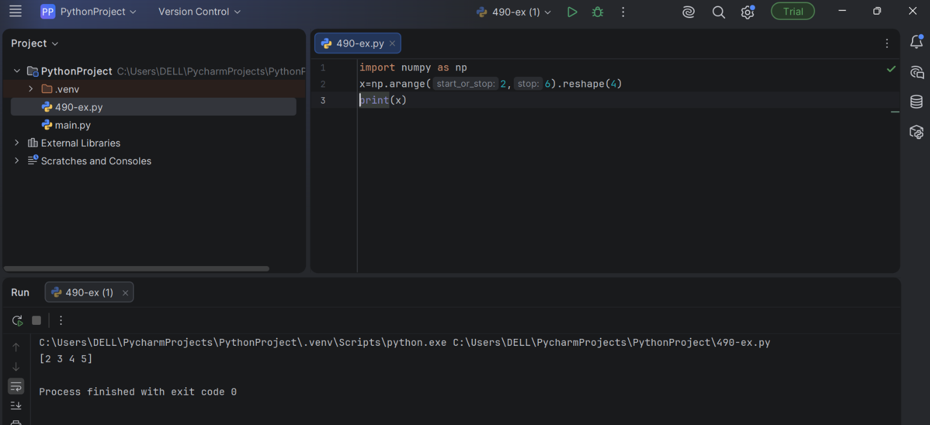

#two dimentional array

import numpy as np x=np.arange(2,10).reshape(2,4) print(x)
output
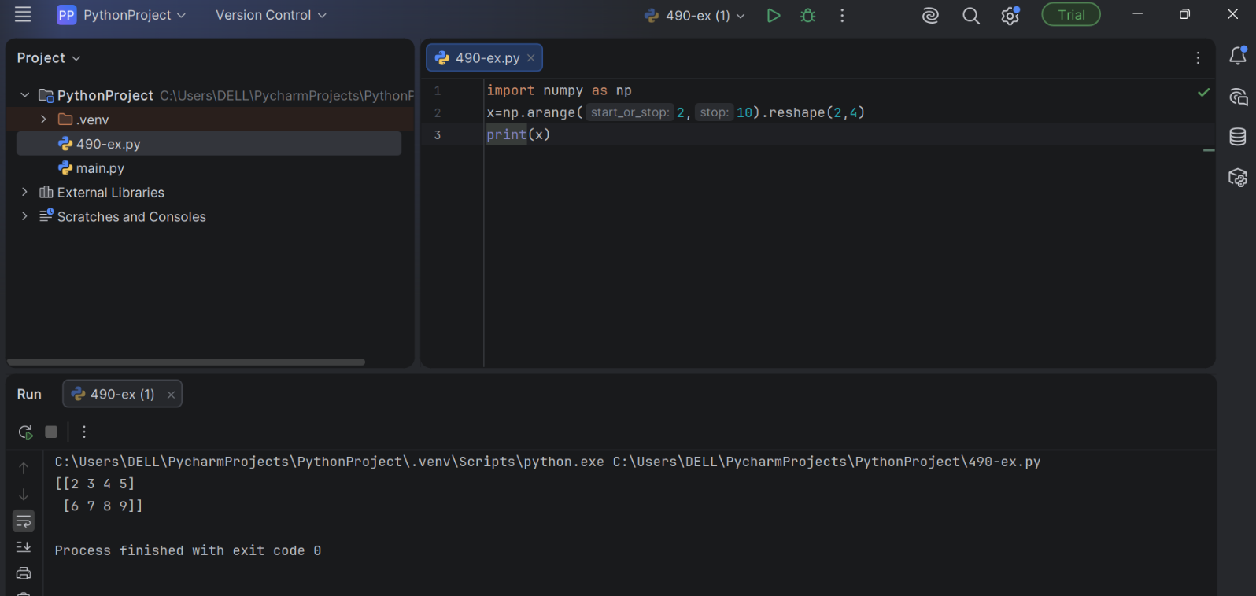
#three dimentional array

import numpy as np x=np.arange(24).reshape(4,3,2) print(x)
output

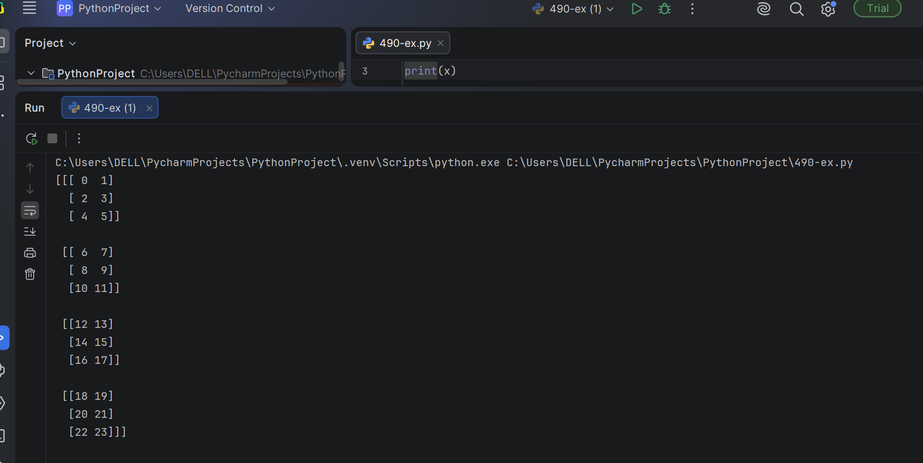

3.Numpy program to perform Array slicing.

Code:
import numpy as np arr=np.array([1,2,3,4])
print(arr[1:3:2])
print(arr[::2])
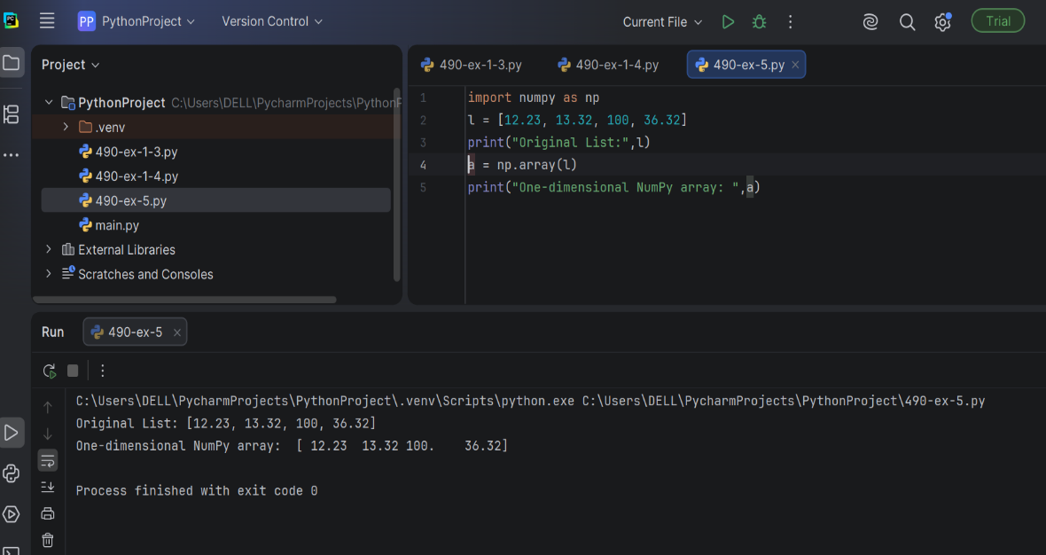
print(arr[:3])

4.Numpy program to perform trigonometric functions.

Code:
import numpy as np arr=np.array([0,30,60,90]) print(np.sin(arr)) print(np.cos(arr)) print(np.tan(arr))
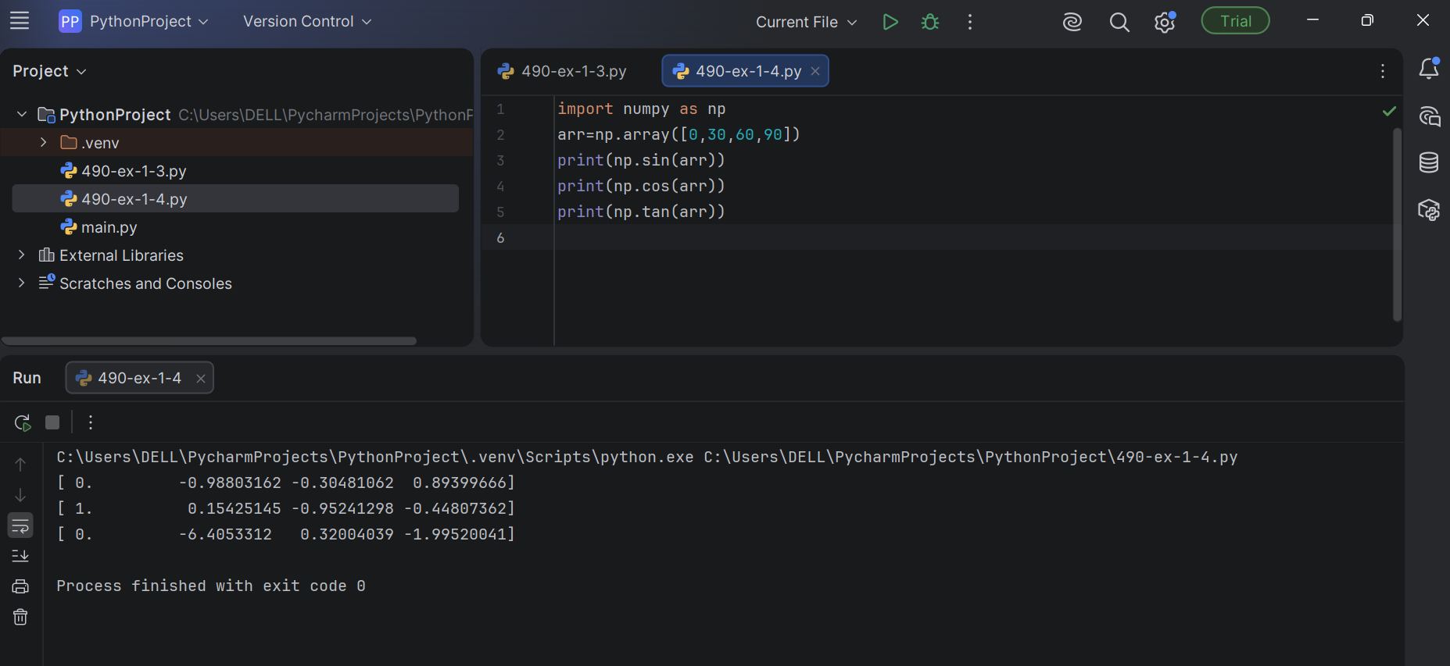

5.NumPy program to convert a list of numeric value into a one-dimensional NumPy array.
Code:
import numpy as np
l = [12.23, 13.32, 100, 36.32]
print("Original List:",l) a = np.array(l)
print("One-dimensional NumPy array: ",a)

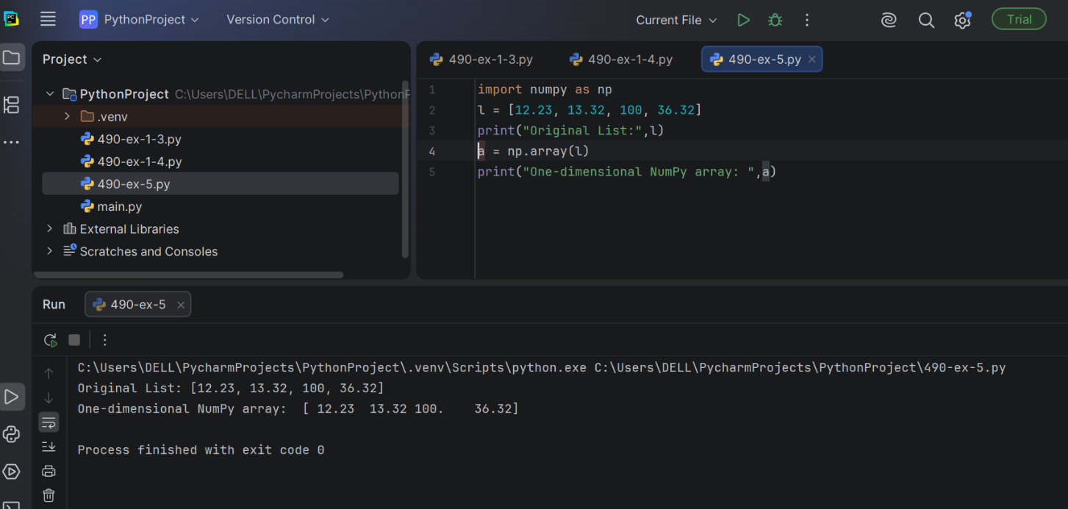

6.NumPy program to create an array with values ranging from 12 to 38.

Code:
import numpy as np x = np.arange(12, 38) print(x)
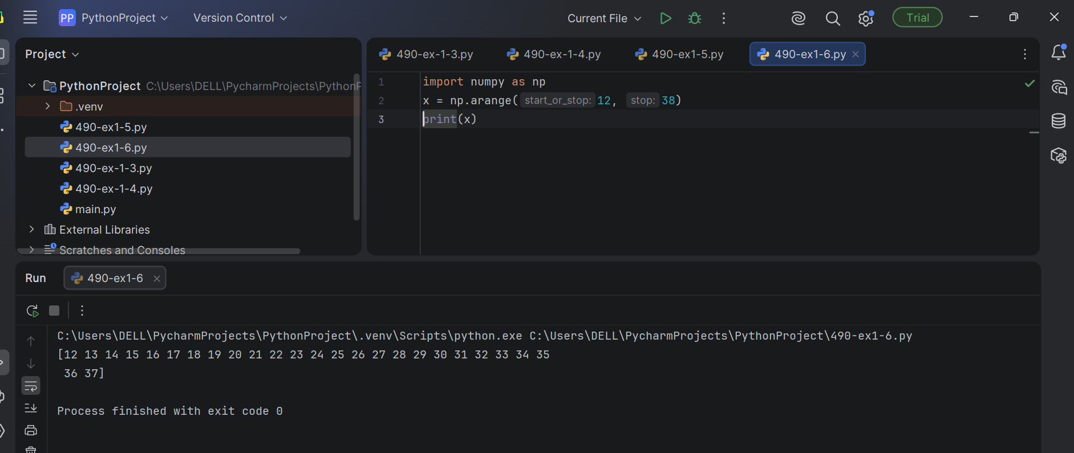

7.NumPy program to reverse an array (first element becomes last).

Code:
import numpy as np import numpy as np x = np.arange(12, 38)
print("Original array:") print(x)
print("Reverse array:") x = x[::-1]
print(x)
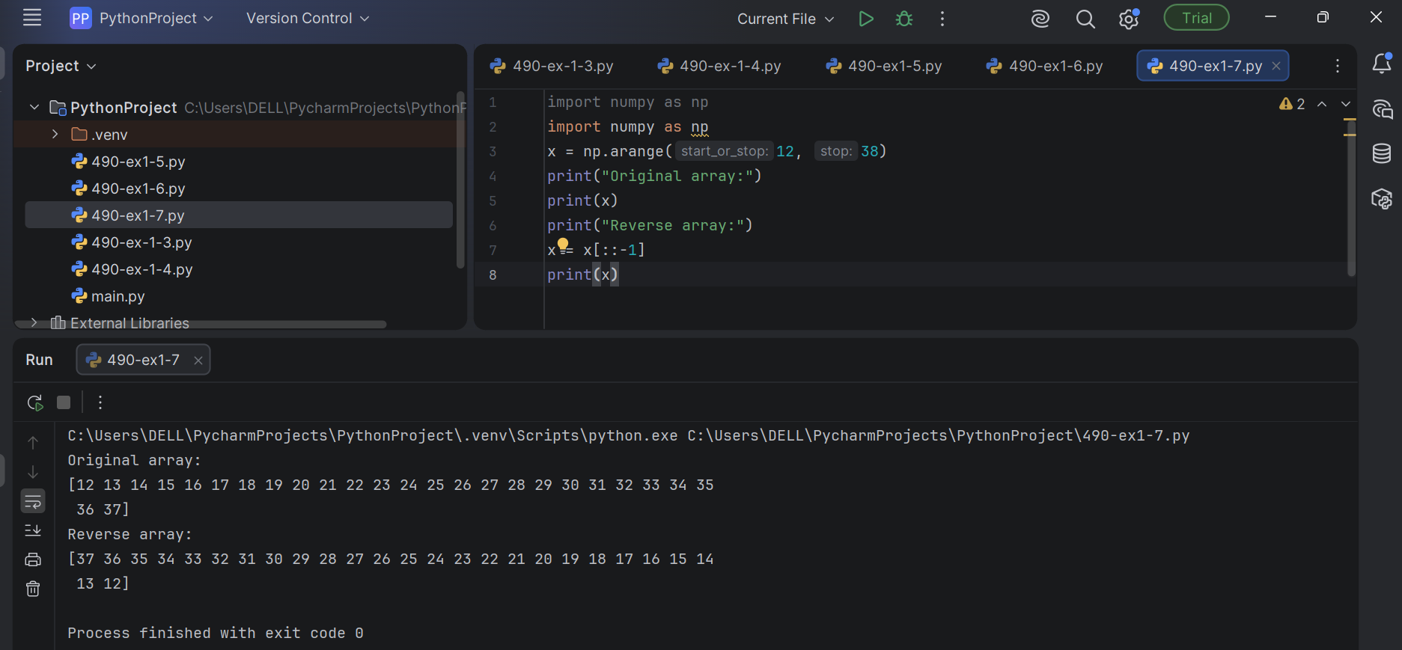

8.NumPy program to append values to the end of an array.

Code:
import numpy as np x = [10, 20, 30]
print("Original array:") print(x)
x = np.append(x, [[40, 50, 60], [70, 80, 90]])
print("After append values to the end of the array:") print(x)

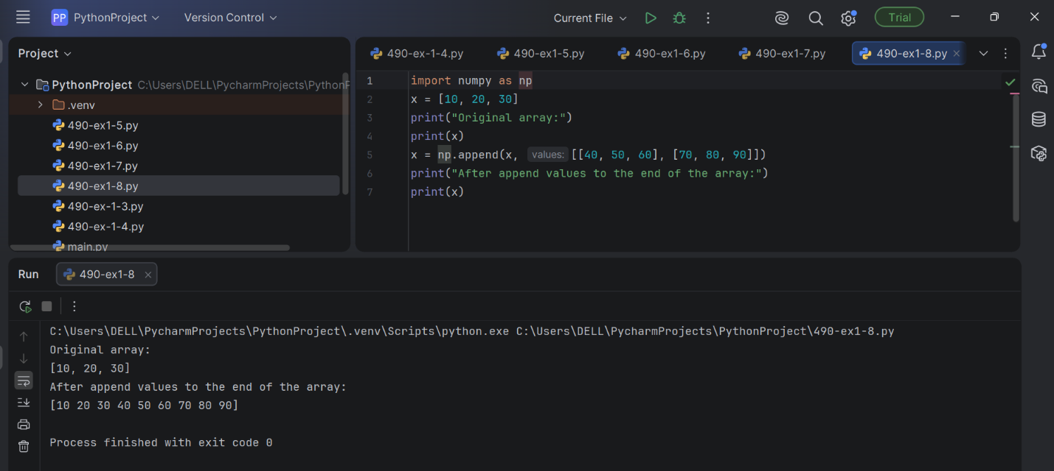

9.NumPy program to find common values between two arrays. Code:
import numpy as np
array1 = np.array([0, 10, 20, 40, 60]) print("Array1: ",array1)
array2 = [10, 30, 40]
print("Array2: ",array2)
print("Common values between two arrays:") print(np.intersect1d(array1, array2))
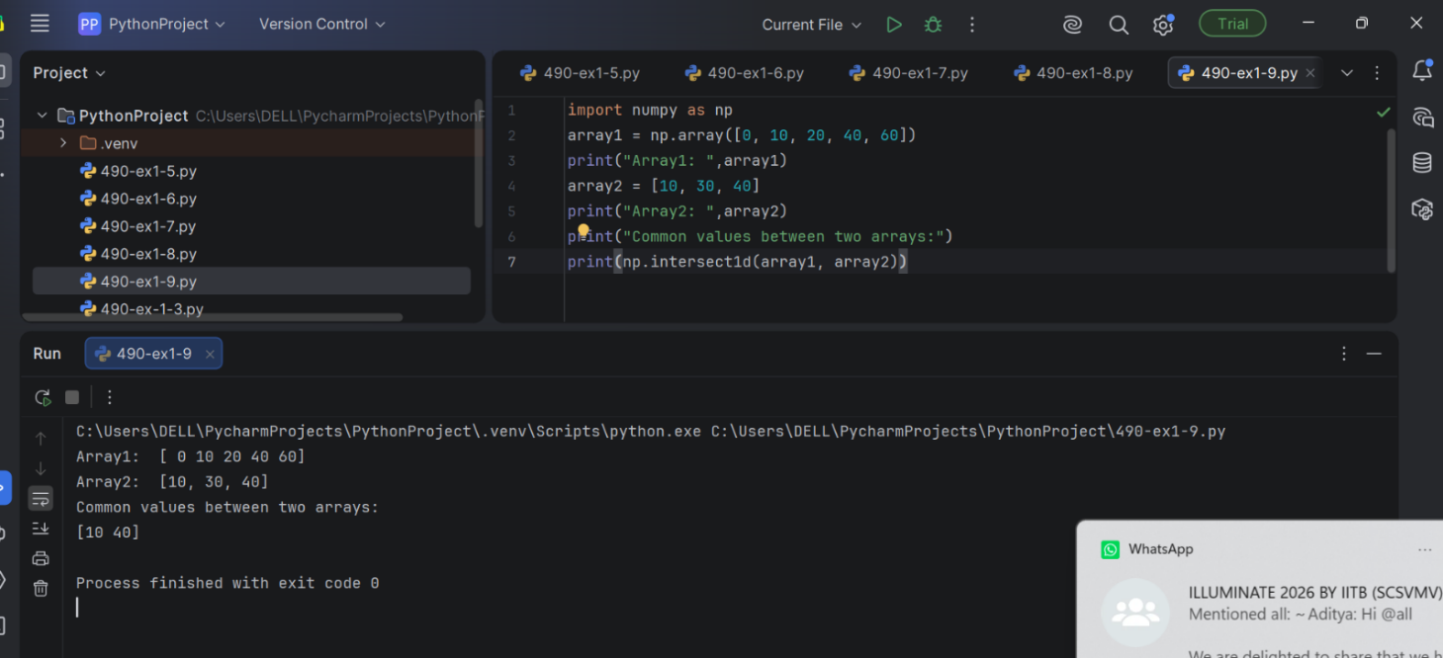

10. NumPy program to find the union of two arrays.

Code:
import numpy as np
array1 = np.array([0, 10, 20, 40, 60, 80]) print("Array1: ",array1)
array2 = [10, 30, 40, 50, 70]
print("Array2: ",array2)
print("Unique sorted array of values that are in either of the two input arrays:") print(np.union1d(array1, array2))
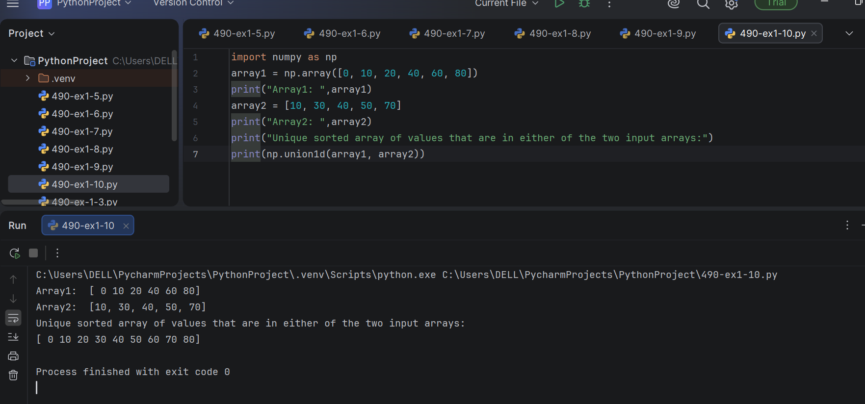

11.NumPy program to concatenate two 2-dimensional arrays.

Code:
import numpy as np
a = np.array([[0, 1, 3], [5, 7, 9]])
b = np.array([[0, 2, 4], [6, 8, 10]])
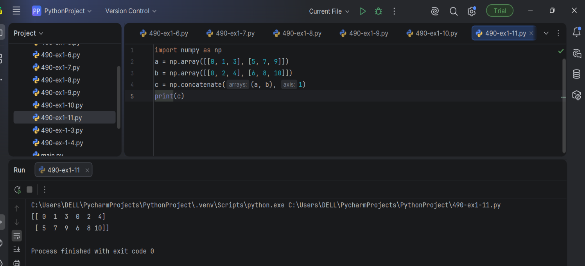
c = np.concatenate((a, b), 1) print(c)

12. Write a NumPy program to convert the values of Centigrade degrees into

Fahrenheit degrees and vice versa.
#Fahrenheit degree to Centigrade degree.

Code:
import numpy as np
fvalues = [0, 12, 45.21, 34, 99.91, 32]
F = np.array(fvalues)
print("Values in Fahrenheit degrees:") print(F)
print("Values in Centigrade degrees:") print(np.round((5*F/9 - 5*32/9),2))

#Centigrade degree to Fahrenheit degree.

Code:
import numpy as np
cvalues = [-17.78, -11.11, 7.34, 1.11, 37.73, 0]
C = np.array(cvalues)
print("Values in Centigrade degrees:") print(C)
print("Values in Fahrenheit degrees:") print(np.round((9*C/5 + 32),2))

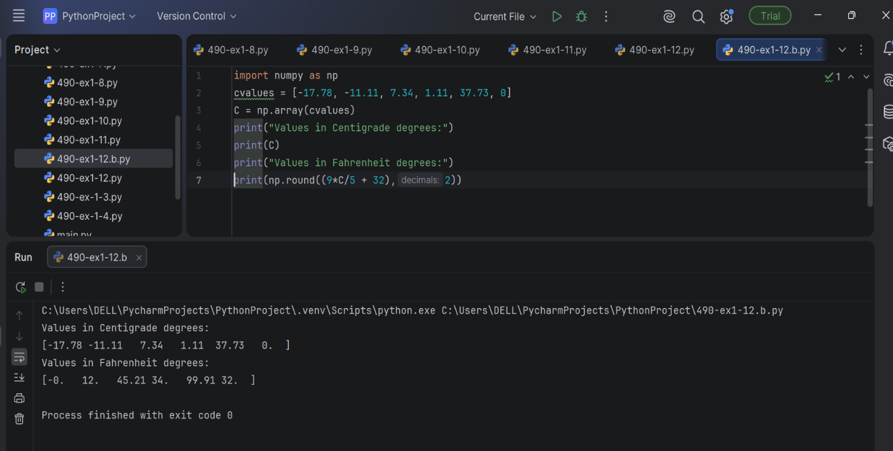

13.Numpy Program to perform arithmetic operations.

Code:
import numpy as np
a=np.arange(9,dtype=np.float_).reshape(3,3) print("First Array:")
print(a) b=np.array([10,20,30]) print("Second Array:") print(b)
print("Addition of Arrays:") print(np.add(a,b)) print("Subtraction of Arrays:") print(np.subtract(a,b)) print("Multiplication of Arrays:") print(np.multiply(a,b)) print("Division of Arrays:") print(np.divide(a,b)

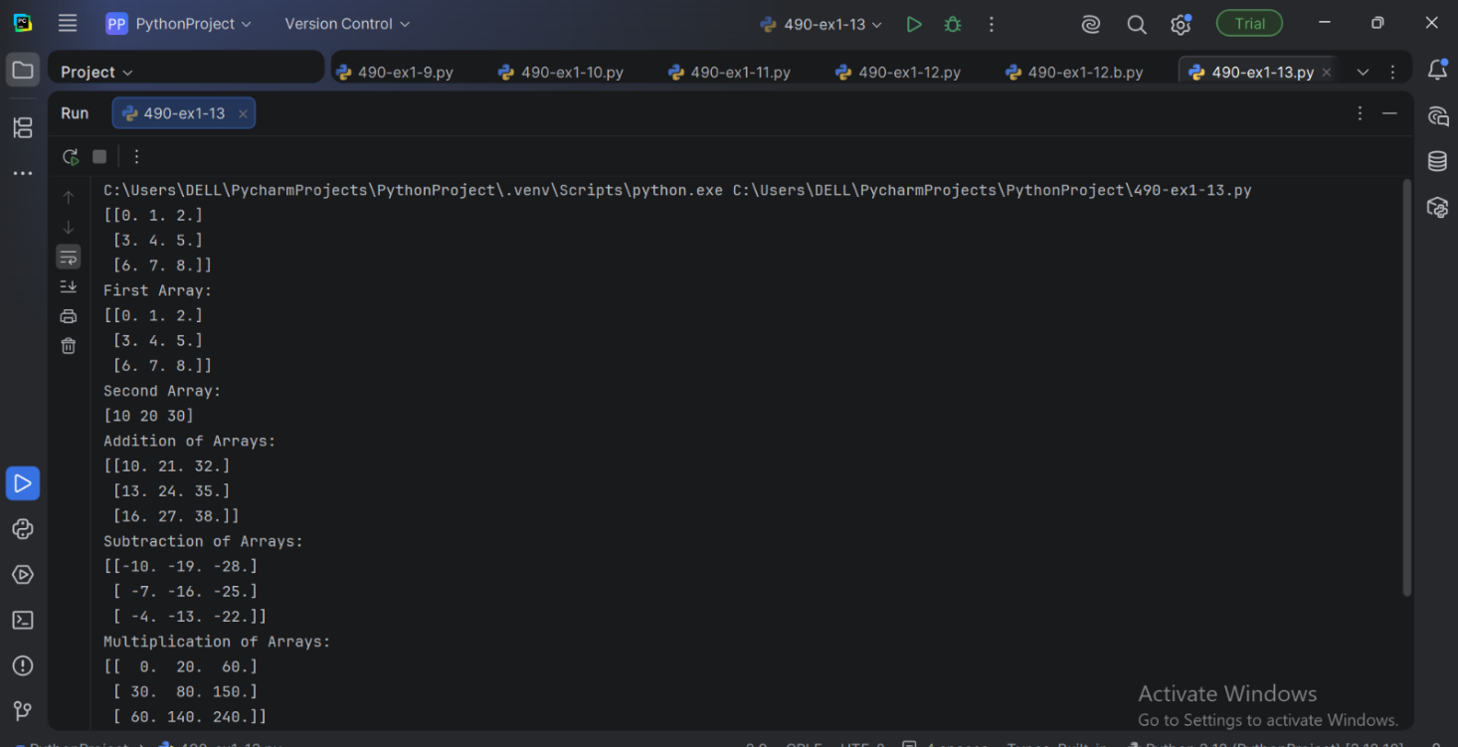

EX-2 : WORKING OF PANDAS DATAFRAME

Program:
- Pandas program to create and display a DataFrame from a specified dictionary data which has the index labels.
Code:
import pandas as pd import numpy as np
exam_data = {'name': ['Anastasia', 'Dima', 'Katherine', 'James', 'Emily', 'Michael', 'Matthew', 'Laura', 'Kevin', 'Jonas'],
'score': [12.5, 9, 16.5, np.nan, 9, 20, 14.5, np.nan, 8, 19],
'attempts': [1, 3, 2, 3, 2, 3, 1, 1, 2, 1],
'qualify': ['yes', 'no', 'yes', 'no', 'no', 'yes', 'yes', 'no', 'no', 'yes']}
labels = ['a', 'b', 'c', 'd', 'e', 'f', 'g', 'h', 'i', 'j']
df = pd.DataFrame(exam_data , index=labels) print(df)

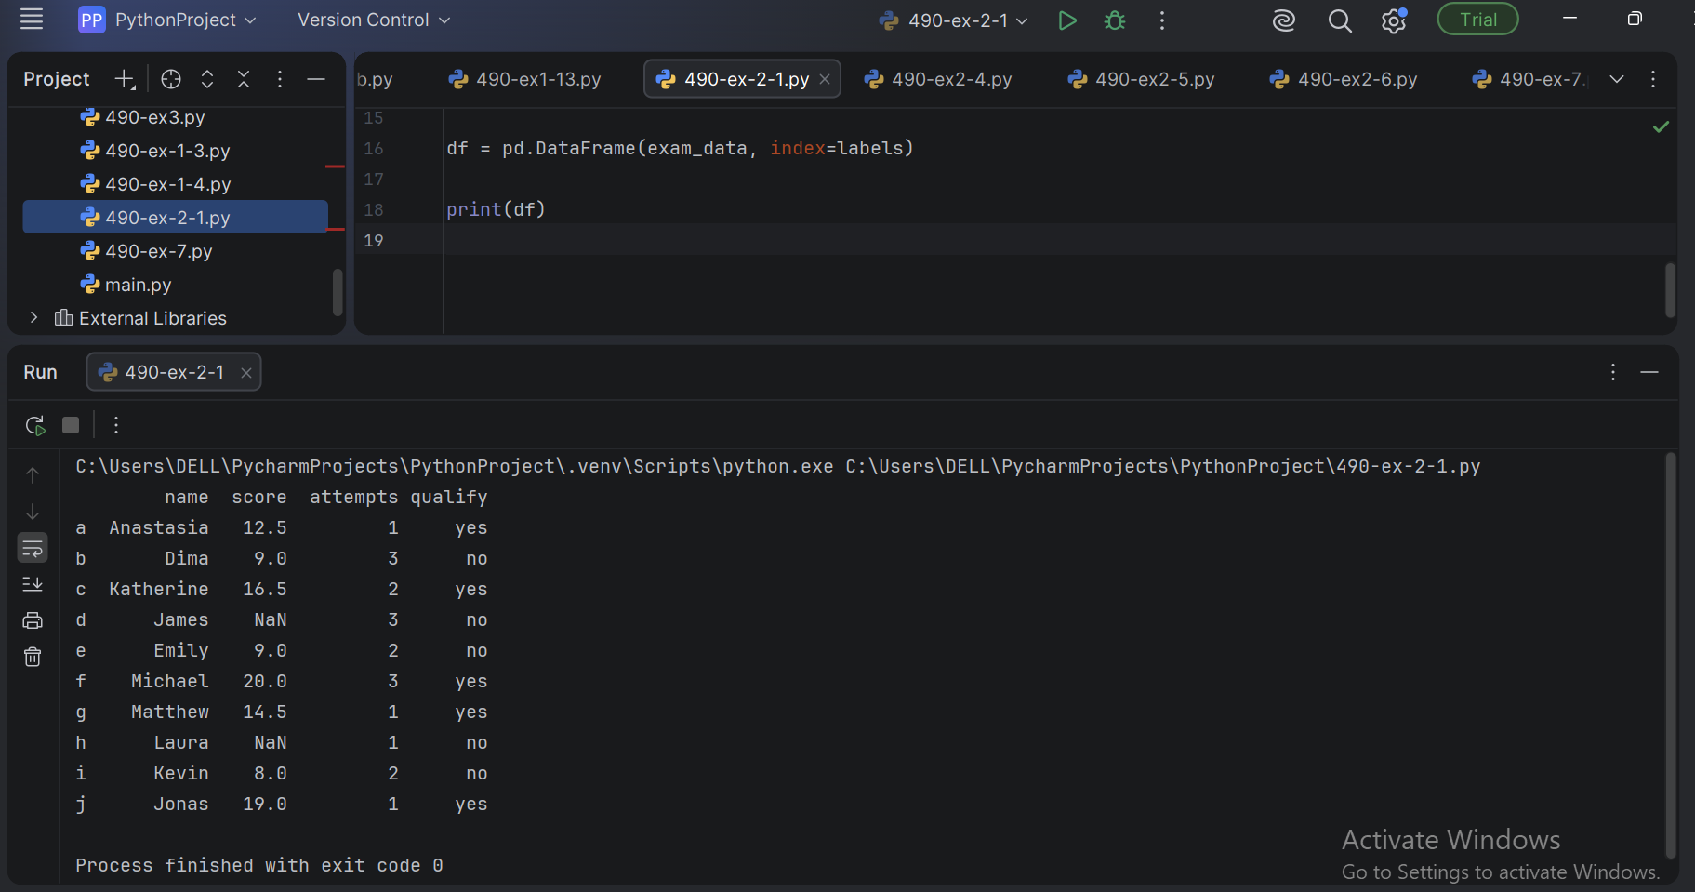

2.Pandas program to display a summary of the basic information about a specified DataFrame and its data.
Code:
df = pd.DataFrame(exam_data , index=labels)
print("Summary of the basic information about this DataFrame and its data:") print(df.info())

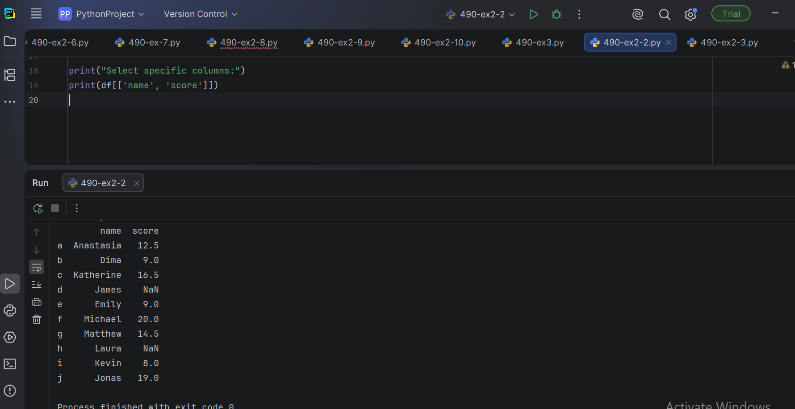

3.Pandas program to get the first 3 rows of a given DataFrame.

Code:

df = pd.DataFrame(exam_data , index=labels) print("First three rows of the data frame:") print(df.iloc[:3])

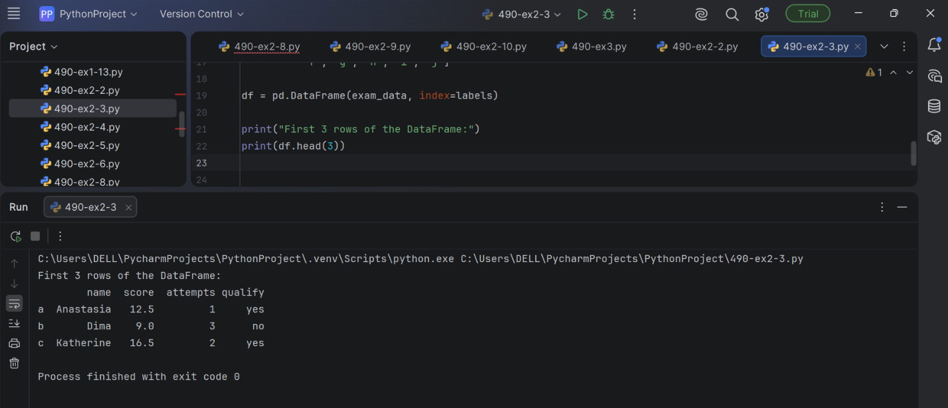

4.Pandas program to select the 'name' and 'score' columns from the following DataFrame.
Code:
df = pd.DataFrame(exam_data , index=labels) print("Select specific columns:") print(df[['name', 'score']]

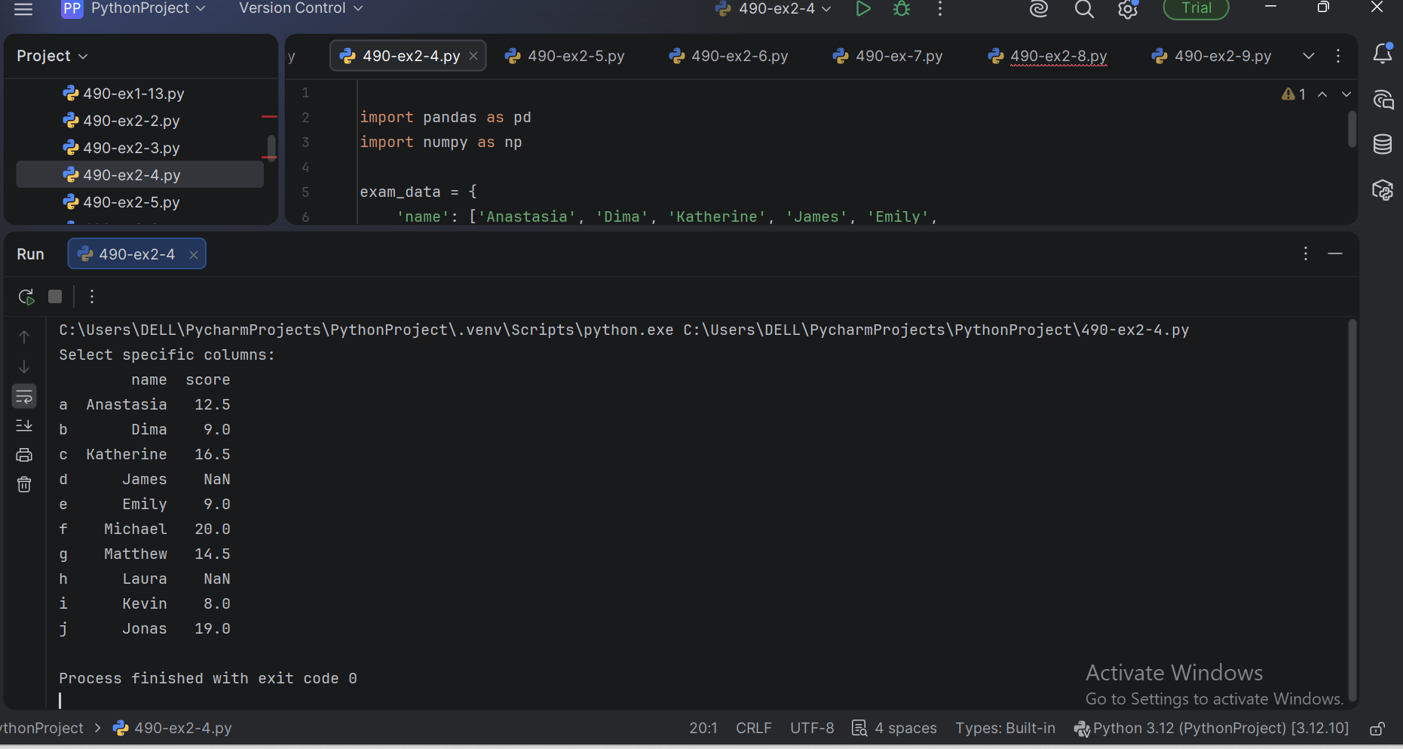

5.Pandas program to select the rows where the number of attempts in the examination is greater than 2.
Code:

df = pd.DataFrame(exam_data , index=labels)
print("Number of attempts in the examination is greater than 2:") print(df[df['attempts'] > 2]
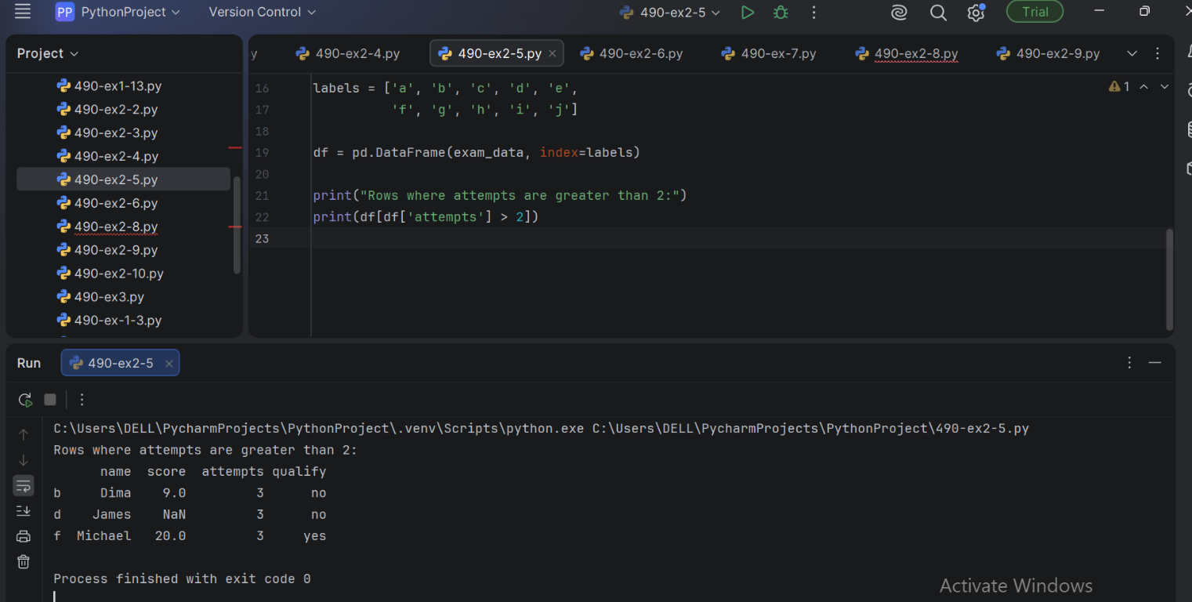

6.Pandas program to count the number of rows and columns of a DataFrame.
Code:

df = pd.DataFrame(exam_data ,
index=labels) total_rows=len(df.axes[0])
total_cols=len(df.axes[1])
print("Number of Rows: "+str(total_rows))
print("Number of Columns: "+str(total_cols))
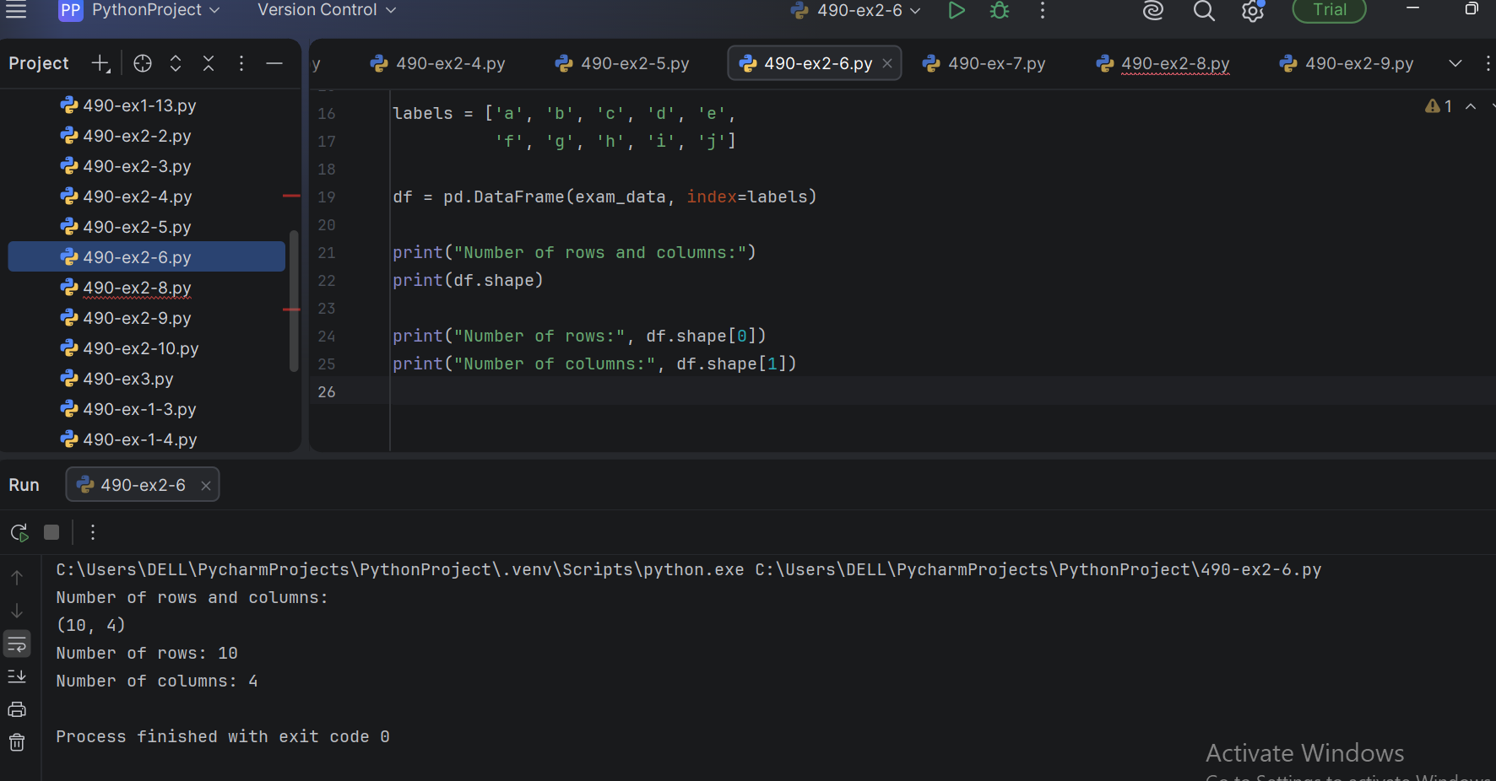

7. Pandas program to select the rows where the score is missing, i.e. is NaN.

Code:

df = pd.DataFrame(exam_data , index=labels) print("Rows where score is missing:") print(df[df['score'].isnull()])
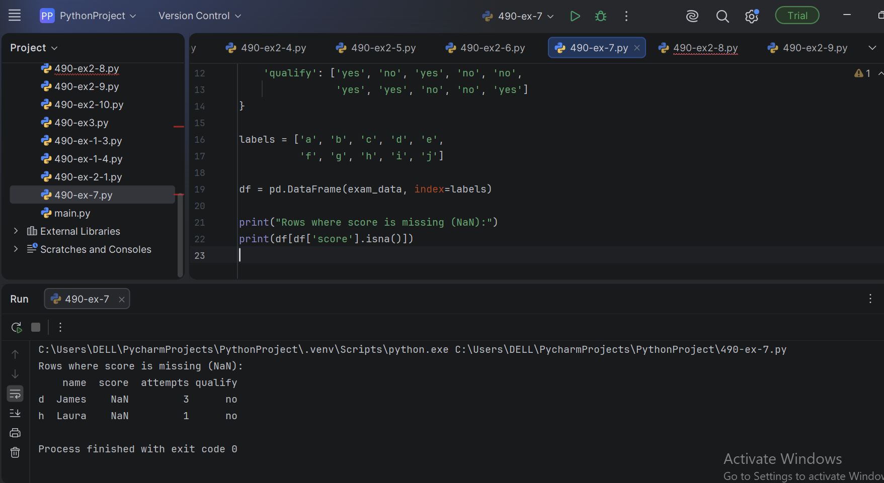

8.Pandas program to append a new row 'k' to DataFrame with given values for

each column Now delete the new row and return the original data frame.

Code:

df = pd.DataFrame(exam_data , index=labels) print("Original rows:")
print(df)
print("\nAppend a new row:") df.loc['k'] = ['Suresh',15.5, 1, 'yes']
print("Print all records after insert a new record:") print(df)
print("\nDelete the new row and display the original rows:") df = df.drop('k')
print(df)

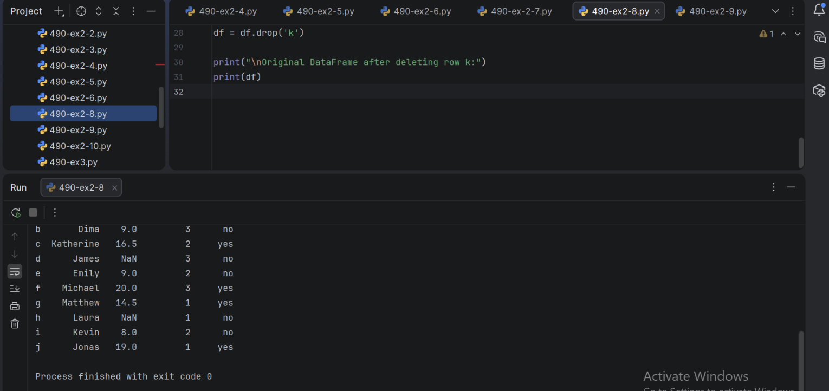

9. Pandas program to sort the DataFrame first by 'name' in descending order, then by 'score' in ascending order.
Code:

df = pd.DataFrame(exam_data , index=labels) print("Orginal rows:")
print(df)
df.sort_values(by=['name', 'score'], ascending=[False, True])
print("Sort the data frame first by ‘name’ in descending order, then by ‘score’ in ascending order:")
print(df)

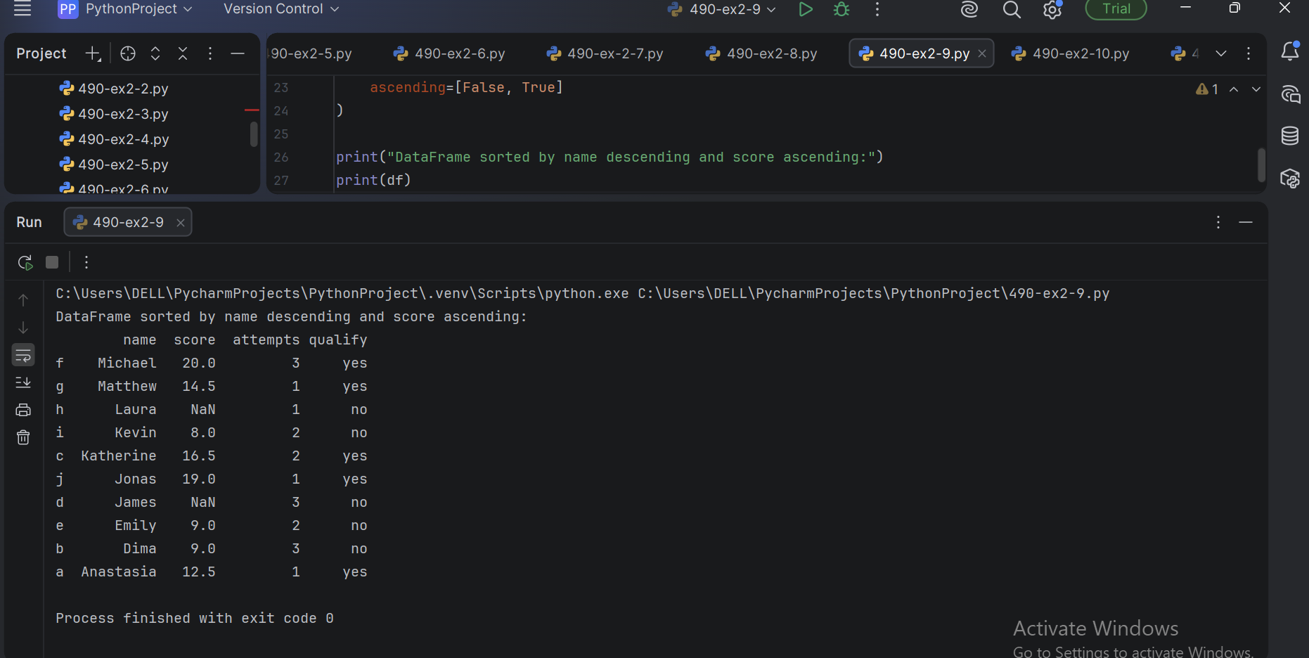

EX-3 : BASIC SCENARIO BASED PROGRAMS USING PYTHON FOR DATASCIENCE
PROGRAM :
1.Student Marks Analysis Program

marks = [78, 85, 92, 67, 88, 90, 76]
print("Highest Mark:", max(marks))
print("Lowest Mark:", min(marks))
print("Average Mark:", sum(marks)/len(marks))

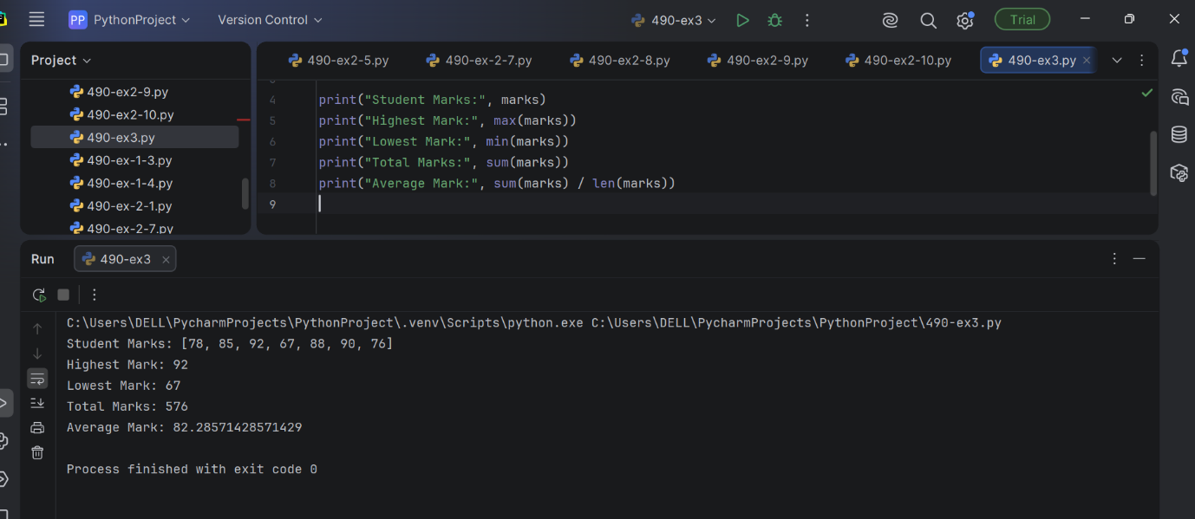

2.Temperature Analysis Program

temperature = [30, 32, 31, 29, 35, 34, 33]
print("Maximum Temperature:", max(temperature))
print("Minimum Temperature:", min(temperature))
print("Average Temperature:", sum(temperature)/len(temperature))

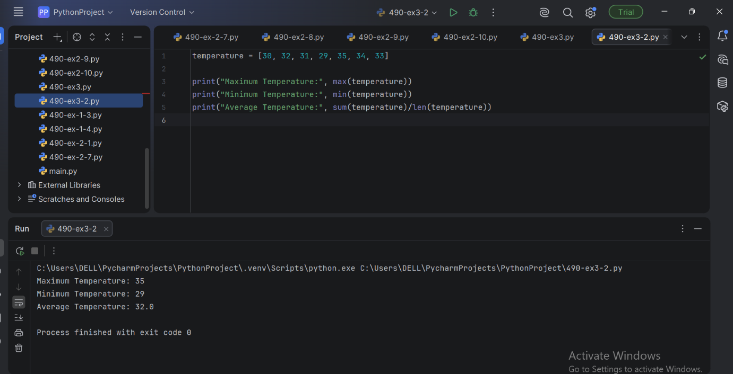

3. Weekly Sales Analysis Program

sales = [2500, 3000, 2800, 3500, 4000, 3800, 4200]
print("Total Sales:", sum(sales))
print("Average Sales:", sum(sales)/len(sales))

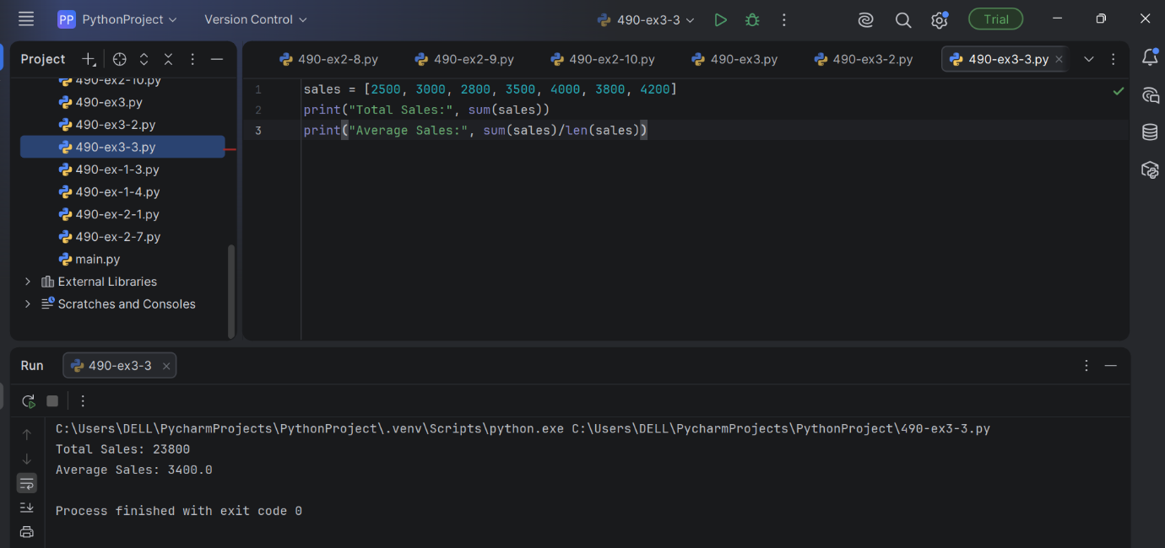

4. Even and Odd Employee IDs Program

ids = [101, 102, 103, 104, 105, 106]
even = []
odd = []
for i in ids:
if i % 2 == 0:
even.append(i)
else:
odd.append(i)
print("Even IDs:", even)
print("Odd IDs:", odd)

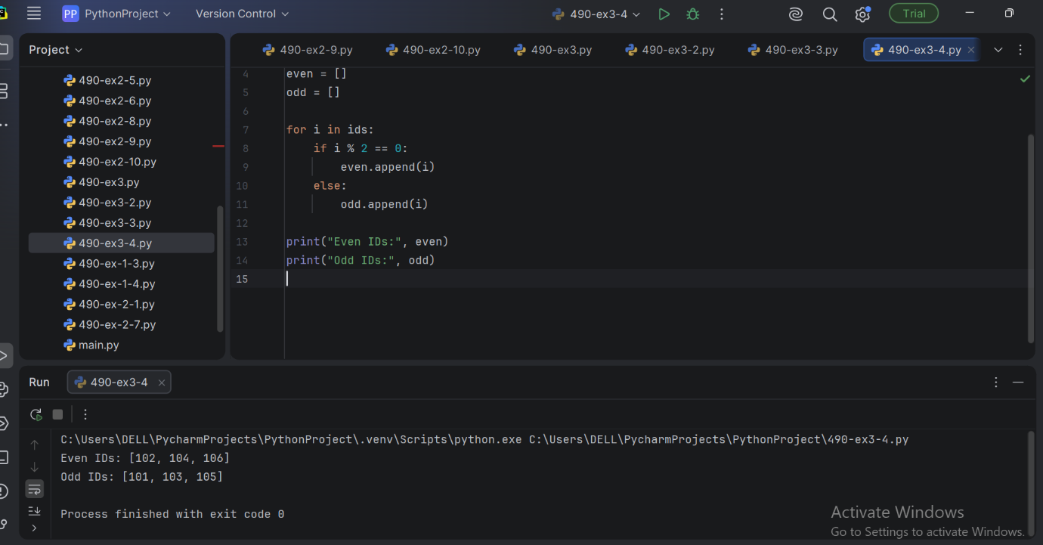

5. Count Positive and Negative Values Program
values = [20, -5, 15, -10, 30, -2]
positive = 0
negative = 0
for i in values:
if i > 0:
positive += 1
elif i < 0:
negative += 1
print("Positive Values:", positive)
print("Negative Values:", negative)

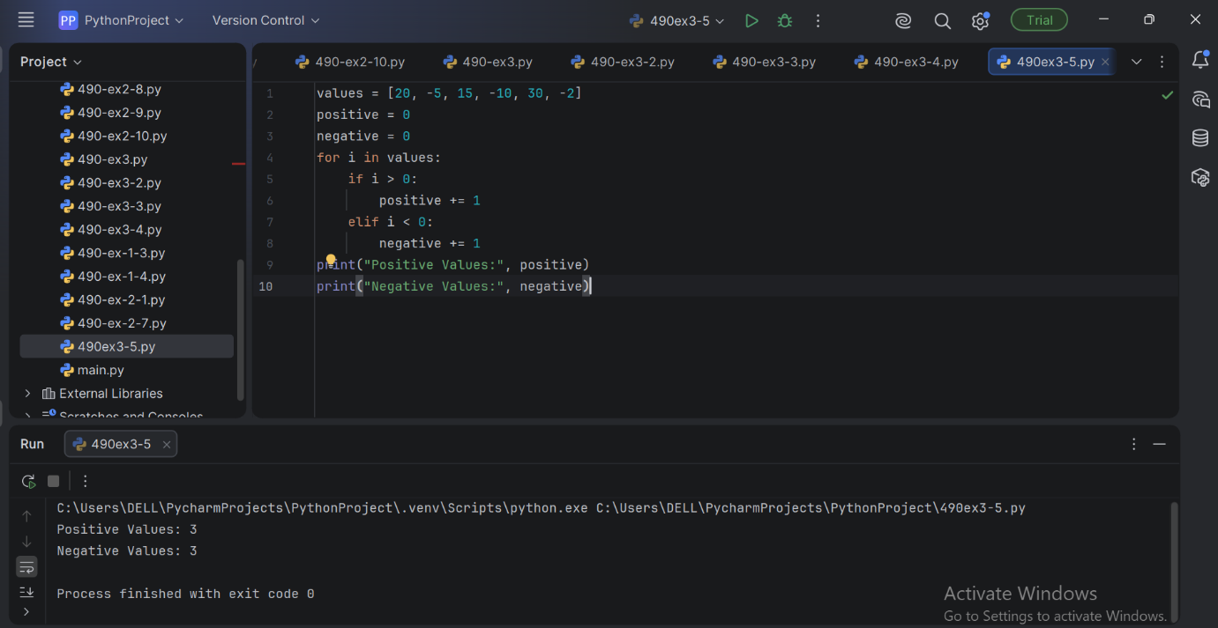

6.Find Duplicate Customer IDs Program

customer_ids = [101, 102, 103, 102, 104, 105, 101]
duplicates = []
for i in customer_ids:
if customer_ids.count(i) > 1 and i not In duplicates:
duplicates.append(i)
print("Duplicate IDs:", duplicates)

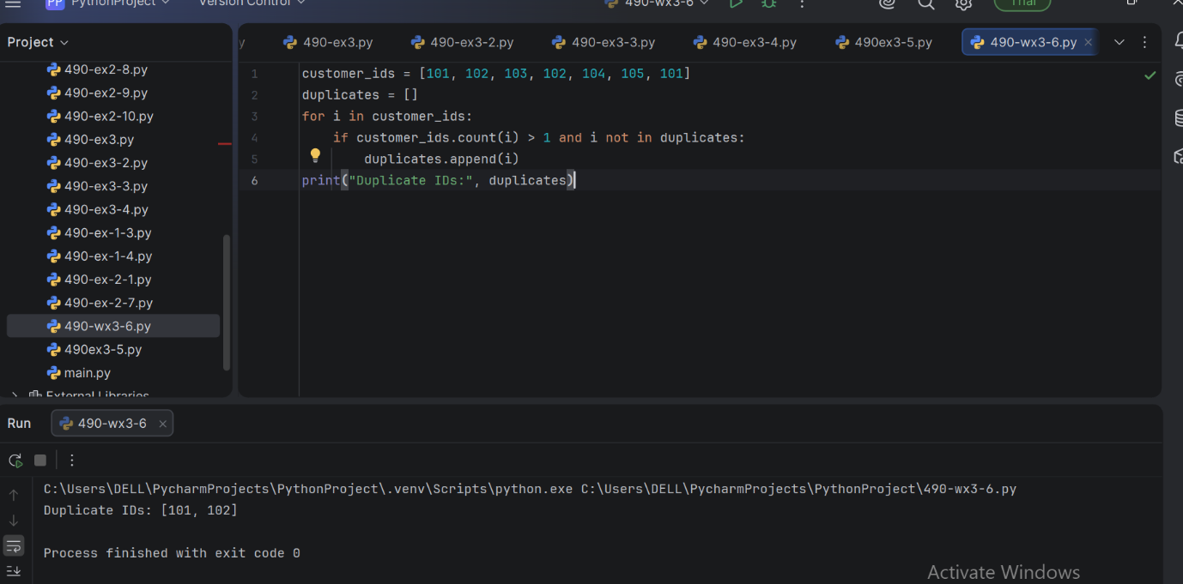

7. Product Price Analysis Program

prices = [250, 450, 120, 600, 350]
print("Highest Price:", max(prices))
print("Lowest Price:", min(prices)

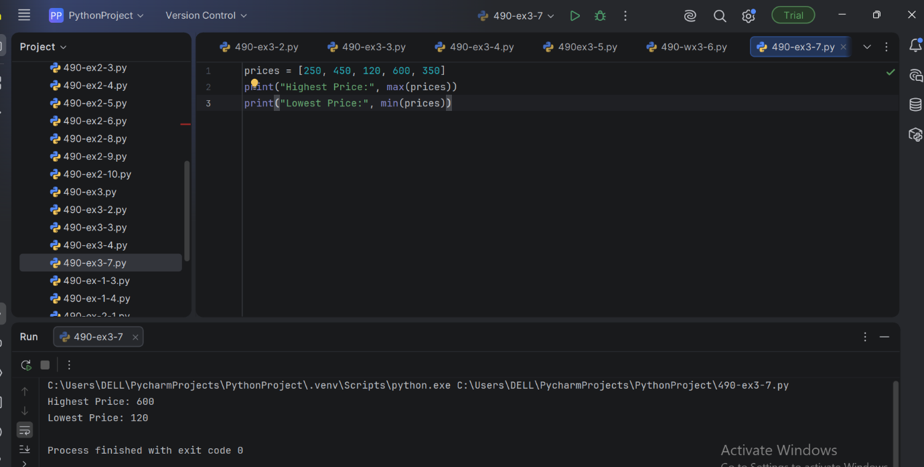

8. Employee Salary Increment Program

salary = [25000, 30000, 40000, 35000]
new_salary = []
for s in salary:
new_salary.append(s * 1.10)
print("Updated Salaries:", new_salary)
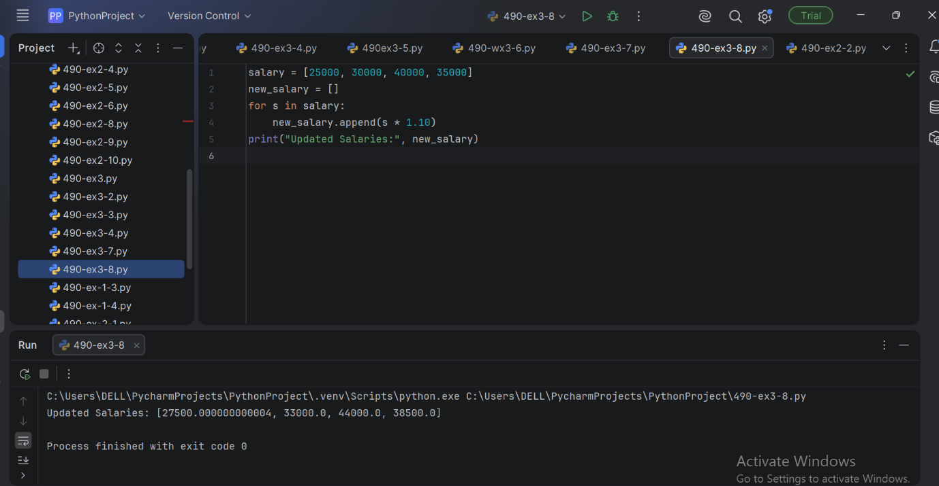

9.Attendance Percentage Program
total_classes = 90
attended = 81
percentage = (attended / total_classes) * 100
print("Attendance Percentage:", percentage)

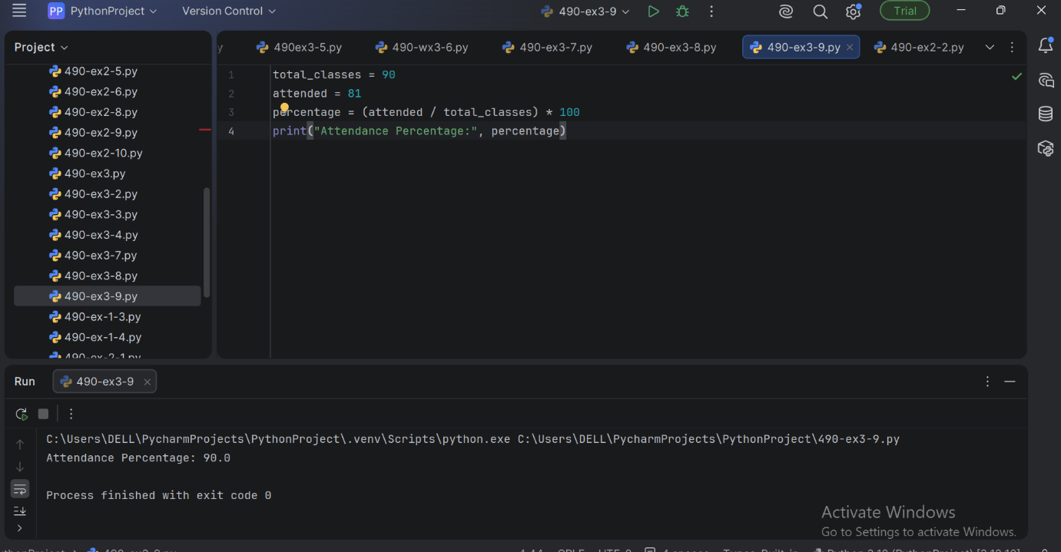

10. Students Who Passed Program

marks = [45, 67, 89, 32, 78, 55, 49]
passed = []
for m in marks:
if m >= 50:
passed.append(m)
print("Passed Students Marks:", passed)

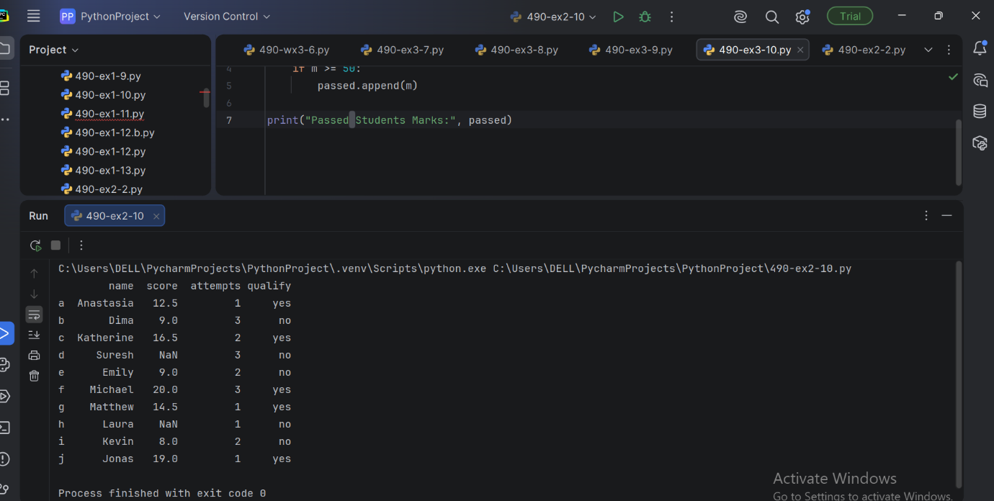

11. Shopping Bill Calculation Program

prices = [120, 80, 150, 200]
total = sum(prices)
print("Total Bill:", total)
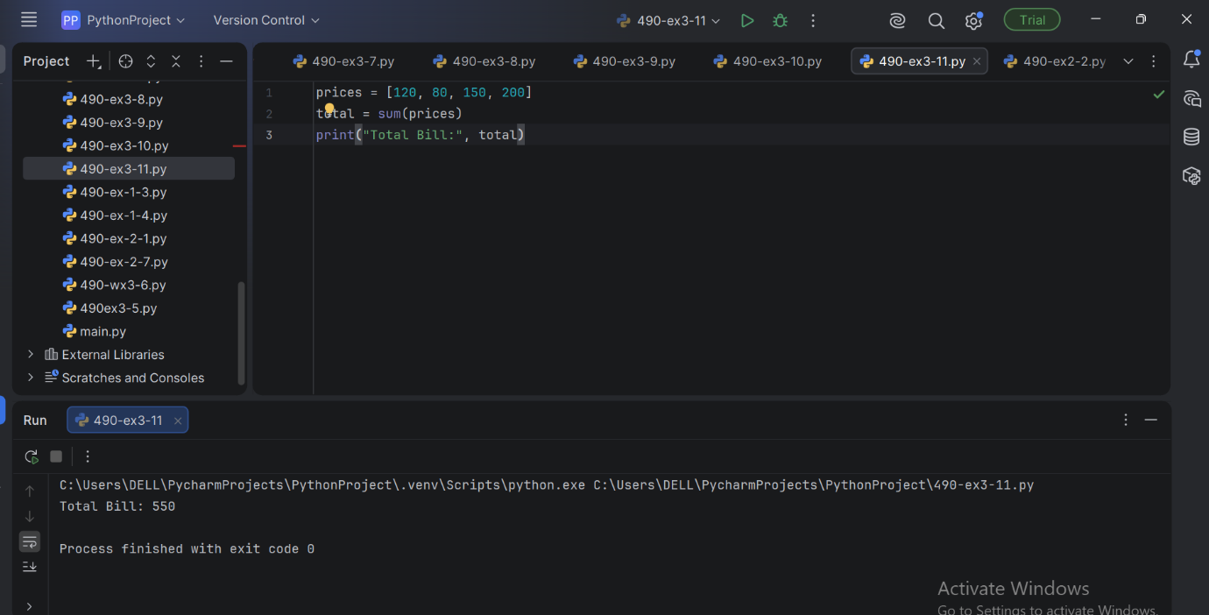

12. Word Frequency Analysis Program
feedback = "good service good quality excellent service"

words = feedback.split()
for word in set(words):
print(word, ":", words.count(word)).
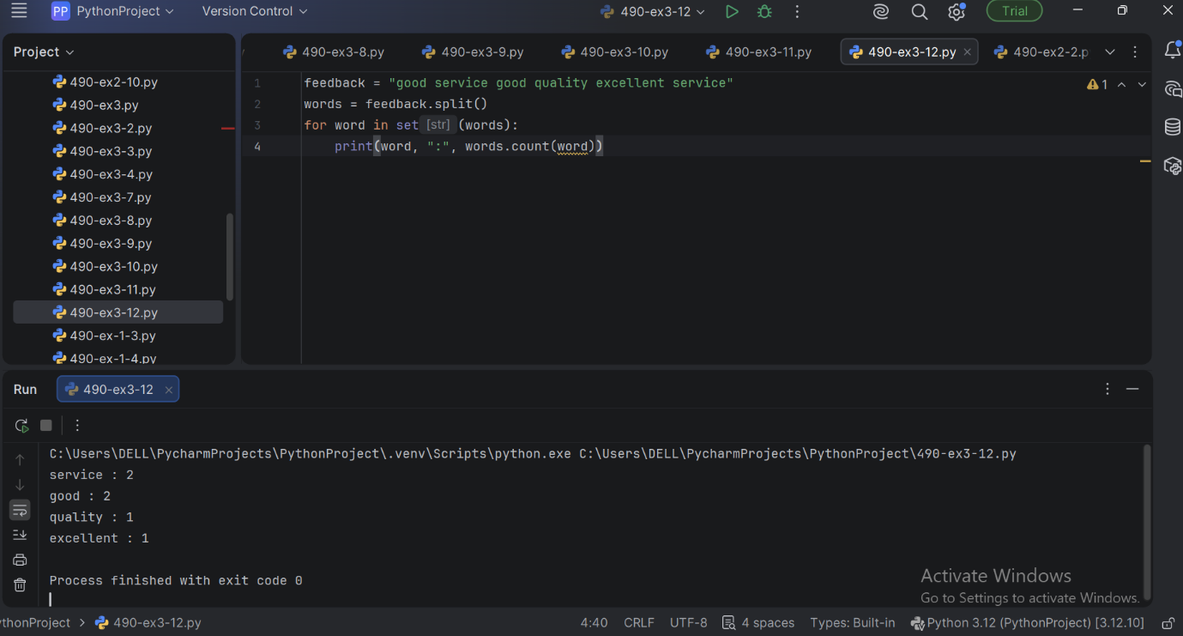

13. Age Group Classification Program
ages = [12, 25, 45, 67, 15]
for age in ages:
if age < 18:
print(age, "Child")
elif age < 60:
print(age, "Adult")
else:
print(age, "Senior Citizen")

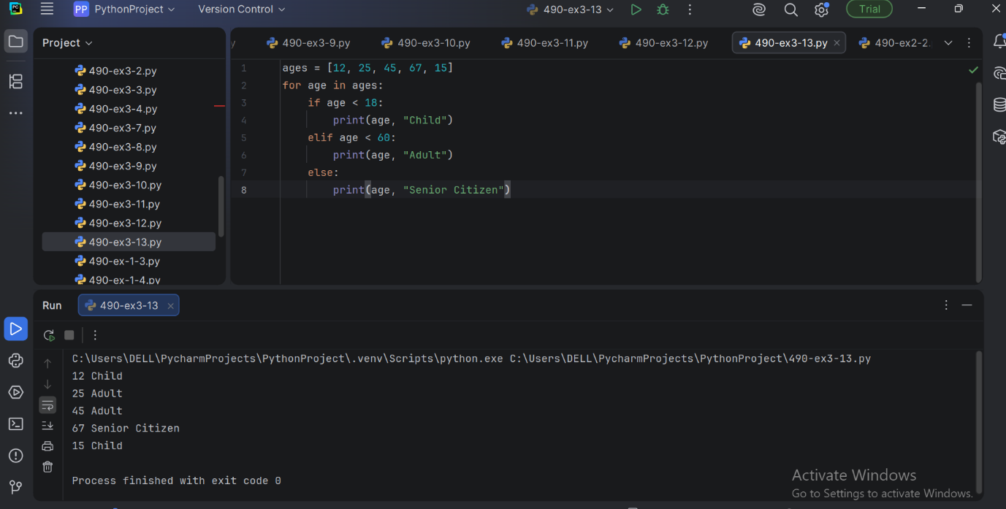

14. Electricity Bill Calculation Program
units = 250
if units <= 100:
bill = units * 2
elif units <= 200:
bill = 100 * 2 + (units - 100) * 3
else:
bill = 100 * 2 + 100 * 3 + (units - 200) * 5
print("Electricity Bill:", bill)

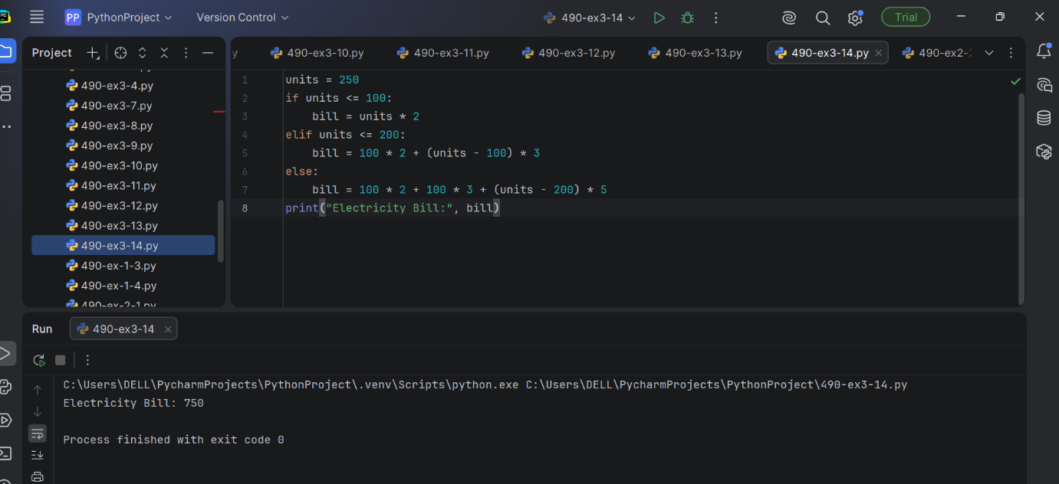

15. Monthly Expense Analysis Program
expenses = [12000, 15000, 18000, 11000, 17000]
highest = max(expenses)
month = expenses.index(highest) + 1
print("Highest Expense:", highest)
print("Month:", month)
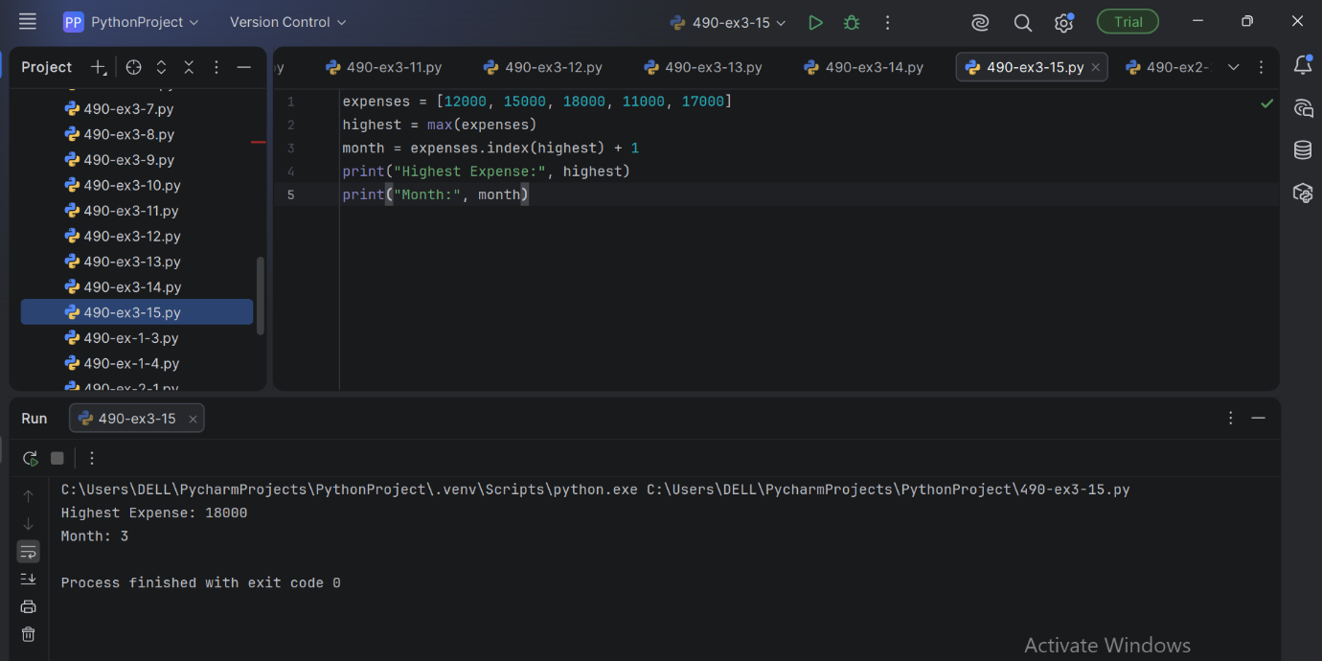

EX-4 : PERFORM DATA PREPROCESSING ON GIVEN DATASET

PROGRAM :
# Import libraries
import pandas as pd
from sklearn.preprocessing import LabelEncoder, StandardScaler
# Load dataset
df = pd.read_csv("Iris.csv")
# Display first 5 records
print("First 5 Records:")
print(df.head())
# Display dataset information
print("\nDataset Information:")
print(df.info())
# Check for missing values
print("\nMissing Values:")
print(df.isnull().sum())
# Remove the Id column (not useful for analysis)
df = df.drop("Id", axis=1)
# Encode the target column (Species)
encoder = LabelEncoder()
df["Species"] = encoder.fit_transform(df["Species"])
print("\nEncoded Species:")
print(df.head())
# Feature Scaling
scaler = StandardScaler()
features = ["SepalLengthCm", "SepalWidthCm",
"PetalLengthCm", "PetalWidthCm"]
df[features] = scaler.fit_transform(df[features])
print("\nPreprocessed Dataset:")
print(df.head())

EX-5 : DATASET SPLITTING AND CROSS-VALIDATION USING IRIS DATASET

PROGRAM :

# Dataset Splitting and Cross-Validation
# Using Iris Dataset

from sklearn.datasets import load_iris
from sklearn.model_selection import train_test_split, KFold, cross_val_score
from sklearn.linear_model import LogisticRegression
from sklearn.metrics import accuracy_score

# --------------------------------------------------
# Step 1: Load the Iris Dataset
# --------------------------------------------------

iris = load_iris()

X = iris.data
y = iris.target

print("Dataset Shape:", X.shape)
print("Number of Samples:", len(X))
print("Number of Features:", X.shape[1])
print("Target Classes:", iris.target_names)

# --------------------------------------------------
# Step 2: Split Dataset into Training and Testing
# --------------------------------------------------

X_train, X_test, y_train, y_test = train_test_split(
X,
y,
test_size=0.20,
random_state=42,
stratify=y
)

print("\nDataset Splitting")
print("-----------------")
print("Training samples:", len(X_train))
print("Testing samples :", len(X_test))

# --------------------------------------------------
# Step 3: Create Logistic Regression Model
# --------------------------------------------------

model = LogisticRegression(max_iter=200)

# Train the model
model.fit(X_train, y_train)

# --------------------------------------------------
# Step 4: Predict Test Data
# --------------------------------------------------

y_pred = model.predict(X_test)

# Calculate test accuracy
accuracy = accuracy_score(y_test, y_pred)

print("\nTest Set Performance")
print("--------------------")
print("Test Accuracy:", round(accuracy, 4))

# --------------------------------------------------

# Step 5: Implement 5-Fold Cross-Validation
# --------------------------------------------------

kf = KFold(
n_splits=5,
shuffle=True,
random_state=42
)

cv_scores = cross_val_score(
model,
X,
y,
cv=kf,
scoring='accuracy'
)

print("\n5-Fold Cross-Validation")
print("-----------------------")

for i, score in enumerate(cv_scores, start=1):
print("Fold", i, "Accuracy:", round(score, 4))

# --------------------------------------------------
# Step 6: Calculate Average Cross-Validation Score
# --------------------------------------------------

print("\nCross-Validation Results")
print("------------------------")
print("Average Accuracy:",
round(cv_scores.mean(), 4))

print("Standard Deviation:",
round(cv_scores.std(), 4))

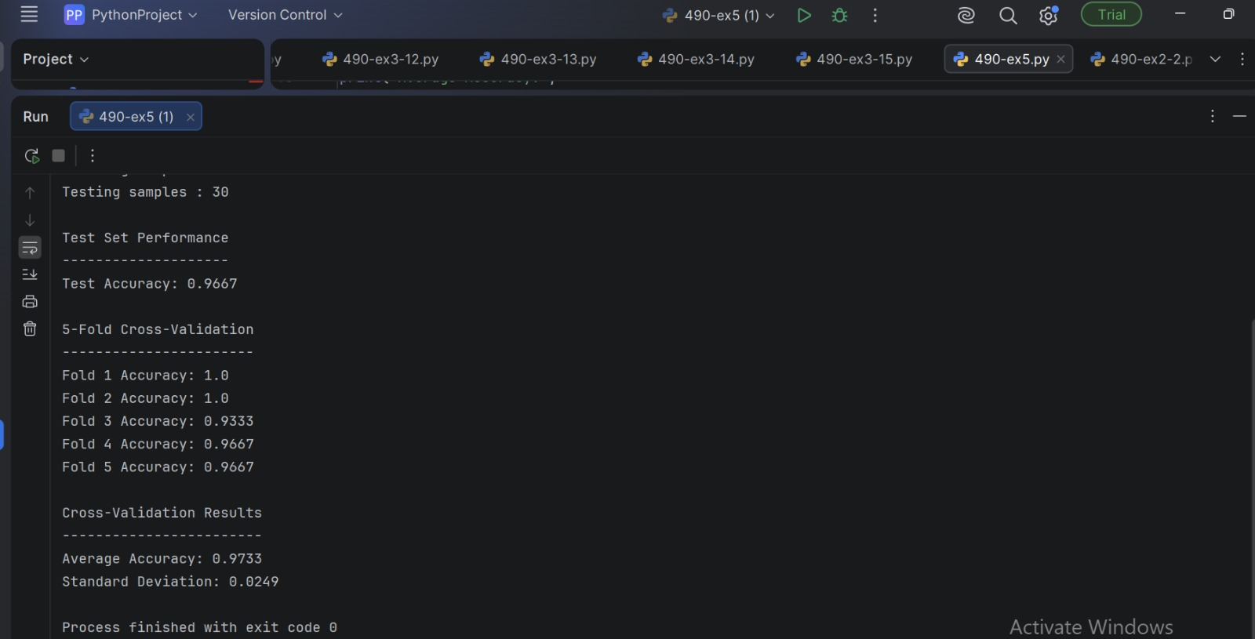

EX-6 : LINEAR REGRESSION USING THE IRIS DATASET

PROGRAM :

from sklearn.datasets import load_iris
from sklearn.model_selection import train_test_split
from sklearn.linear_model import LinearRegression
from sklearn.metrics import mean_squared_error, mean_absolute_error, r2_score
import numpy as np

# -------------------------------------------------
# Step 1: Load Iris Dataset
# -------------------------------------------------

iris = load_iris()

X = iris.data
feature_names = iris.feature_names

# Predict Petal Length
# Column 2 = Petal Length
y = iris.data[:, 2]

# Use Sepal Length, Sepal Width and Petal Width
# as input features
X = iris.data[:, [0, 1, 3]]

print("Features:")
print(feature_names)

print("\nDataset Shape:", X.shape)
print("Target Shape:", y.shape)

# -------------------------------------------------
# Step 2: Split Dataset
# -------------------------------------------------

X_train, X_test, y_train, y_test = train_test_split(
X,
y,
test_size=0.20,
random_state=42
)

print("\nTraining Samples:", len(X_train))
print("Testing Samples :", len(X_test))

# -------------------------------------------------
# Step 3: Create Linear Regression Model
# -------------------------------------------------

model = LinearRegression()

# -------------------------------------------------
# Step 4: Train the Model
# -------------------------------------------------

model.fit(X_train, y_train)

# -------------------------------------------------
# Step 5: Make Predictions
# -------------------------------------------------

y_pred = model.predict(X_test)

# -------------------------------------------------
# Step 6: Display Predictions
# -------------------------------------------------

print("\nActual vs Predicted Values")
print("--------------------------------")

for actual, predicted in zip(y_test[:10], y_pred[:10]):
print("Actual:", round(actual, 2),
" Predicted:", round(predicted, 2))

# -------------------------------------------------
# Step 7: Evaluate the Model
# -------------------------------------------------

mse = mean_squared_error(y_test, y_pred)

rmse = np.sqrt(mse)

mae = mean_absolute_error(y_test, y_pred)

r2 = r2_score(y_test, y_pred)

print("\nModel Evaluation")
print("-----------------------------")
print("Mean Squared Error (MSE):", round(mse, 4))
print("Root Mean Squared Error (RMSE):", round(rmse, 4))
print("Mean Absolute Error (MAE):", round(mae, 4))
print("R2 Score:", round(r2, 4))

# -------------------------------------------------
# Step 8: Display Model Coefficients

# -------------------------------------------------

print("\nModel Coefficients")
print("-----------------------------")

for name, coefficient in zip(
["Sepal Length", "Sepal Width", "Petal Width"],
model.coef_):

print(name, ":", round(coefficient, 4))

print("Intercept:", round(model.intercept_, 4)

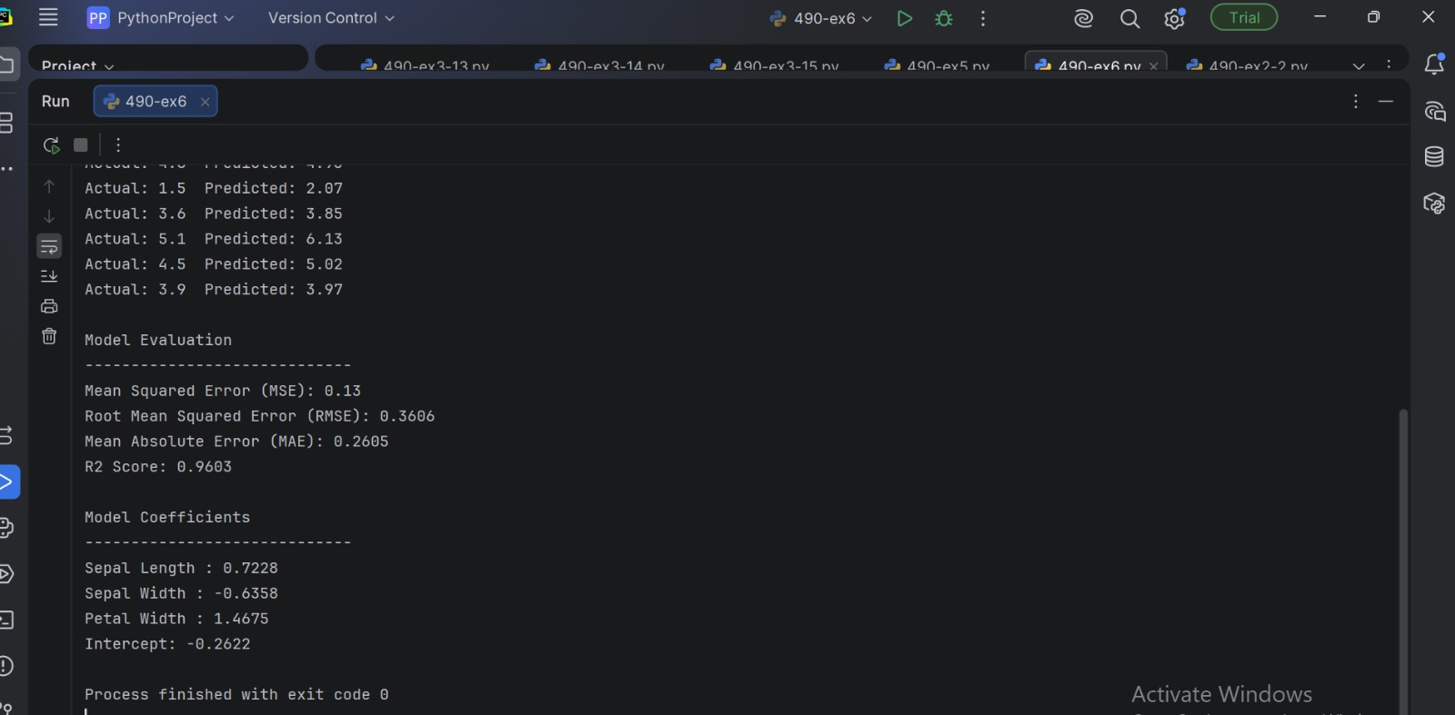

EX-7 : KNN CLASSIFICATION USING IRIS DATASET

PROGRAM :
from sklearn.datasets import load_iris
from sklearn.model_selection import train_test_split
from sklearn.preprocessing import StandardScaler
from sklearn.neighbors import KNeighborsClassifier
from sklearn.metrics import (
accuracy_score,
confusion_matrix,
precision_score,
recall_score,
f1_score
)

# --------------------------------------------------
# Step 1: Load Iris Dataset
# --------------------------------------------------

iris = load_iris()

X = iris.data
y = iris.target

print("Dataset Shape:", X.shape)
print("Number of Samples:", len(X))
print("Number of Features:", X.shape[1])
print("Target Classes:", iris.target_names)

# --------------------------------------------------
# Step 2: Split Dataset
# --------------------------------------------------

X_train, X_test, y_train, y_test = train_test_split(
X,
y,
test_size=0.20,
random_state=42,
stratify=y
)

print("\nDataset Splitting")
print("-----------------")
print("Training samples:", len(X_train))
print("Testing samples :", len(X_test))

# --------------------------------------------------
# Step 3: Feature Scaling
# --------------------------------------------------

scaler = StandardScaler()

X_train = scaler.fit_transform(X_train)
X_test = scaler.transform(X_test)

# --------------------------------------------------
# Step 4: Create KNN Model
# --------------------------------------------------

knn = KNeighborsClassifier(n_neighbors=5)

# --------------------------------------------------
# Step 5: Train the Model
# --------------------------------------------------

knn.fit(X_train, y_train)

# --------------------------------------------------
# Step 6: Make Predictions
# --------------------------------------------------

y_pred = knn.predict(X_test)

# --------------------------------------------------
# Step 7: Calculate Evaluation Metrics
# --------------------------------------------------

accuracy = accuracy_score(y_test, y_pred)

cm = confusion_matrix(y_test, y_pred)

precision = precision_score(
y_test,
y_pred,
average='weighted'
)

recall = recall_score(
y_test,
y_pred,
average='weighted'
)

f1 = f1_score(
y_test,
y_pred,
average='weighted'
)

# --------------------------------------------------

# Step 8: Display Results

# --------------------------------------------------

print("\nKNN Model Evaluation")
print("--------------------")

print("Accuracy :", round(accuracy, 4))
print("Precision:", round(precision, 4))
print("Recall :", round(recall, 4))
print("F1-Score :", round(f1, 4))

print("\nConfusion Matrix")
print("----------------")
print(cm)

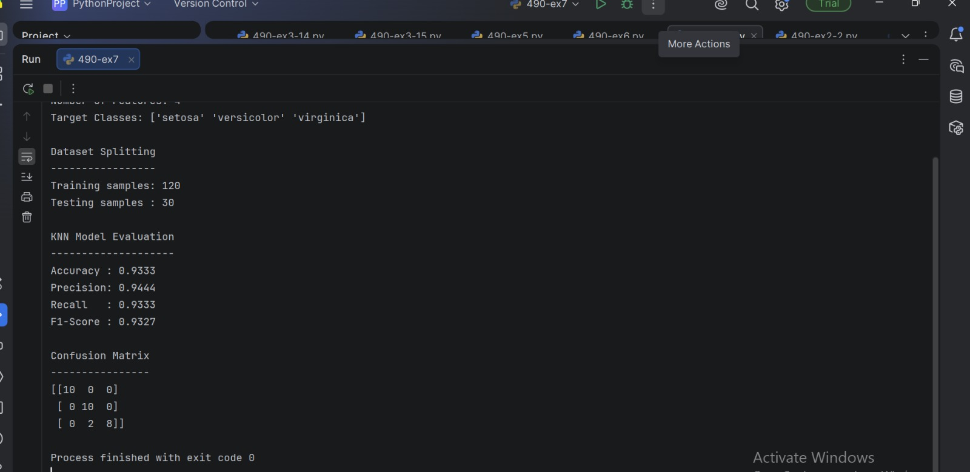

EX-8 : SVM CLASSIFICATION USING IRIS DATASET

PROGRAM :

from sklearn.datasets import load_iris
from sklearn.model_selection import train_test_split
from sklearn.preprocessing import StandardScaler
from sklearn.svm import SVC
from sklearn.metrics import (
accuracy_score,
confusion_matrix,
precision_score,
recall_score,
f1_score
)

# --------------------------------------------------
# Step 1: Load Iris Dataset
# --------------------------------------------------

iris = load_iris()

X = iris.data
y = iris.target

print("Dataset Shape:", X.shape)
print("Number of Samples:", len(X))
print("Number of Features:", X.shape[1])
print("Target Classes:", iris.target_names)

# --------------------------------------------------
# Step 2: Split Dataset
# --------------------------------------------------

X_train, X_test, y_train, y_test = train_test_split(
X,
y,
test_size=0.20,
random_state=42,
stratify=y
)

print("\nDataset Splitting")
print("-----------------")
print("Training samples:", len(X_train))
print("Testing samples :", len(X_test))

# --------------------------------------------------
# Step 3: Feature Scaling

# --------------------------------------------------

scaler = StandardScaler()

X_train = scaler.fit_transform(X_train)
X_test = scaler.transform(X_test)

# --------------------------------------------------
# Step 4: Create SVM Model
# --------------------------------------------------

model = SVC(
kernel='linear',
C=1.0
)

# --------------------------------------------------
# Step 5: Train the Model
# --------------------------------------------------

model.fit(X_train, y_train)

# --------------------------------------------------
# Step 6: Make Predictions
# --------------------------------------------------

y_pred = model.predict(X_test)

# --------------------------------------------------
# Step 7: Calculate Evaluation Metrics
# --------------------------------------------------

accuracy = accuracy_score(y_test, y_pred)

cm = confusion_matrix(y_test, y_pred)

precision = precision_score(
y_test,
y_pred,
average='weighted'
)

recall = recall_score(
y_test,
y_pred,
average='weighted'
)

f1 = f1_score(
y_test,

y_pred,
average='weighted'
)

# --------------------------------------------------
# Step 8: Display Results
# --------------------------------------------------

print("\nSVM Model Evaluation")
print("--------------------")

print("Accuracy :", round(accuracy, 4))
print("Precision:", round(precision, 4))
print("Recall :", round(recall, 4))
print("F1-Score :", round(f1, 4))

print("\nConfusion Matrix")
print("----------------")
print(cm)

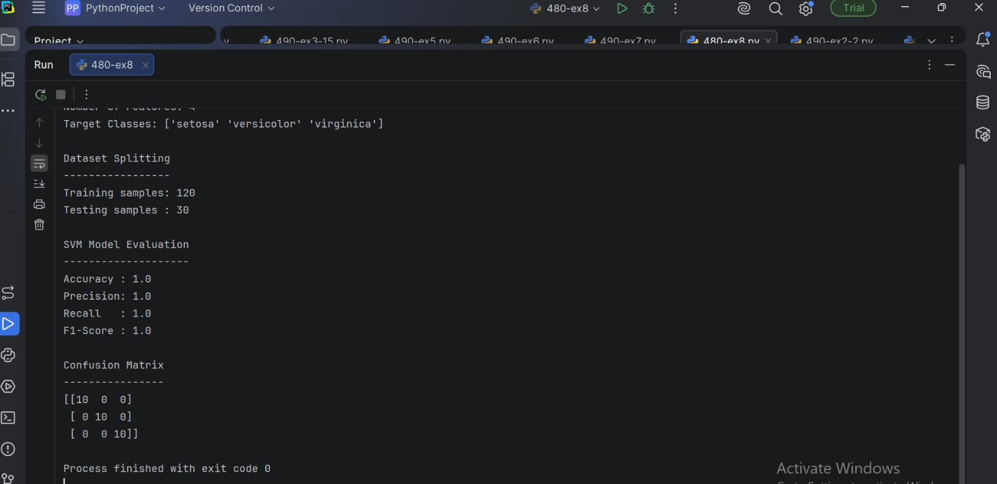

EX-9
PROGRAM :

# K-Means Clustering using Iris Dataset

from sklearn.datasets import load_iris
from sklearn.cluster import KMeans
from sklearn.preprocessing import StandardScaler
from sklearn.metrics import silhouette_score
import matplotlib.pyplot as plt

# --------------------------------------------------
# Step 1: Load Iris Dataset
# --------------------------------------------------

iris = load_iris()

X = iris.data
y = iris.target

print("Dataset Shape:", X.shape)
print("Number of Samples:", X.shape[0])
print("Number of Features:", X.shape[1])

print("\nFeatures:")
print(iris.feature_names)

# --------------------------------------------------
# Step 2: Feature Scaling
# --------------------------------------------------

scaler = StandardScaler()
X_scaled = scaler.fit_transform(X)

# --------------------------------------------------
# Step 3: Create K-Means Model
# --------------------------------------------------

kmeans = KMeans(
n_clusters=3,
random_state=42,
n_init=10
)

# --------------------------------------------------
# Step 4: Fit K-Means Model
# --------------------------------------------------

kmeans.fit(X_scaled)

# --------------------------------------------------
# Step 5: Get Cluster Labels
# --------------------------------------------------

labels = kmeans.labels_

# --------------------------------------------------
# Step 6: Get Cluster Centroids
# --------------------------------------------------

centroids = kmeans.cluster_centers_

# --------------------------------------------------
# Step 7: Display Results
# --------------------------------------------------

print("\nCluster Labels:")
print(labels)

print("\nCluster Centroids:")
print(centroids)

# --------------------------------------------------
# Step 8: Calculate Silhouette Score
# --------------------------------------------------

silhouette = silhouette_score(X_scaled, labels)

print("\nCluster Evaluation")
print("------------------")
print("Silhouette Score:",
round(silhouette, 4))

# --------------------------------------------------
# Step 9: Display Cluster Count
# --------------------------------------------------

print("\nNumber of Samples in Each Cluster:")

for i in range(3):
print(
"Cluster", i,
":",
sum(labels == i),
"samples"
)

# --------------------------------------------------
# Step 10: Visualize Clusters
# --------------------------------------------------

plt.figure(figsize=(8, 6))

plt.scatter(
X_scaled[:, 2],
X_scaled[:, 3],
c=labels
)

plt.scatter(
centroids[:, 2],
centroids[:, 3],
marker='X',
s=200
)

plt.xlabel("Petal Length")
plt.ylabel("Petal Width")
plt.title("K-Means Clustering on Iris Dataset")

plt.show()

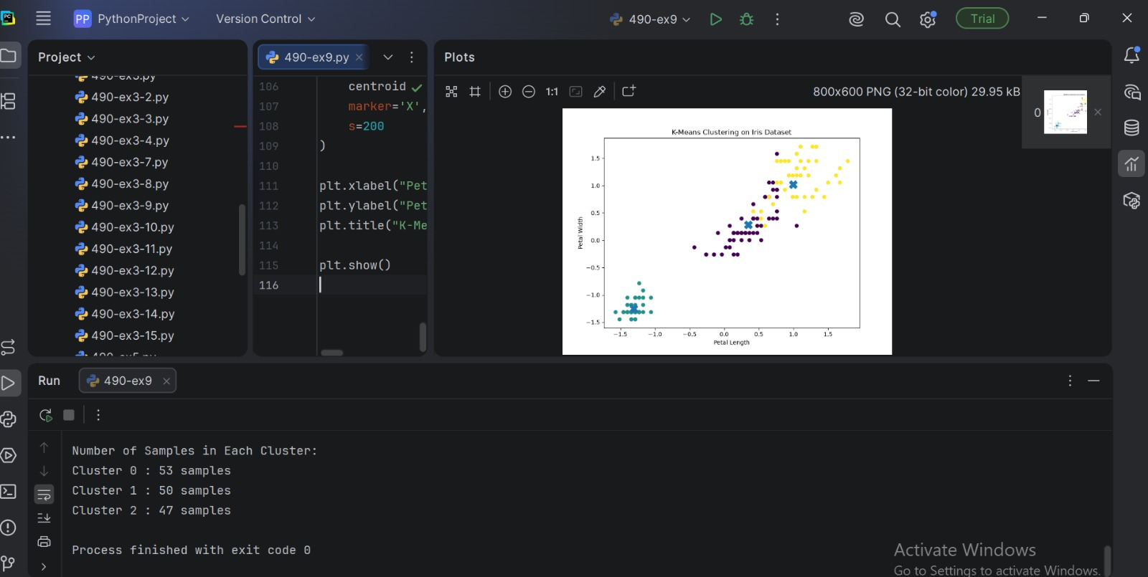

EX-10 : HIERARCHICAL CLUSTERING USING IRIS DATSET

PROGRAM :

# Hierarchical Clustering using Iris Dataset

import matplotlib.pyplot as plt

from sklearn.datasets import load_iris
from sklearn.preprocessing import StandardScaler
from sklearn.cluster import AgglomerativeClustering
from sklearn.metrics import silhouette_score

from scipy.cluster.hierarchy import dendrogram, linkage

# --------------------------------------------------
# Step 1: Load Iris Dataset
# --------------------------------------------------

iris = load_iris()

X = iris.data
y = iris.target

print("Dataset Shape:", X.shape)
print("Number of Samples:", X.shape[0])
print("Number of Features:", X.shape[1])

print("\nFeatures:")
print(iris.feature_names)

# --------------------------------------------------
# Step 2: Feature Scaling
# --------------------------------------------------

scaler = StandardScaler()
X_scaled = scaler.fit_transform(X)

# --------------------------------------------------
# Step 3: Create Dendrogram
# --------------------------------------------------

linked = linkage(X_scaled, method='ward')

plt.figure(figsize=(10, 6))

dendrogram(
linked,
truncate_mode='lastp',
p=20
)

plt.title("Hierarchical Clustering Dendrogram")
plt.xlabel("Data Points / Clusters")
plt.ylabel("Distance")

plt.show()

# --------------------------------------------------
# Step 4: Apply Agglomerative Clustering
# --------------------------------------------------

model = AgglomerativeClustering(
n_clusters=3,
linkage='ward'
)

labels = model.fit_predict(X_scaled)

# --------------------------------------------------
# Step 5: Display Cluster Labels
# --------------------------------------------------

print("\nCluster Labels:")
print(labels)

# --------------------------------------------------
# Step 6: Calculate Silhouette Score
# --------------------------------------------------

silhouette = silhouette_score(
X_scaled,
labels
)

print("\nSilhouette Score:",
round(silhouette, 4))

# --------------------------------------------------
# Step 7: Count Samples in Each Cluster
# --------------------------------------------------

print("\nNumber of Samples in Each Cluster:")

for i in range(3):
print(
"Cluster", i,
":",
sum(labels == i),
"samples"

)

# --------------------------------------------------
# Step 8: Visualize Clusters
# --------------------------------------------------

plt.figure(figsize=(8, 6))

plt.scatter(
X_scaled[:, 2],
X_scaled[:, 3],
c=labels
)

plt.xlabel("Petal Length")
plt.ylabel("Petal Width")
plt.title("Hierarchical Clustering on Iris Dataset")

plt.show()

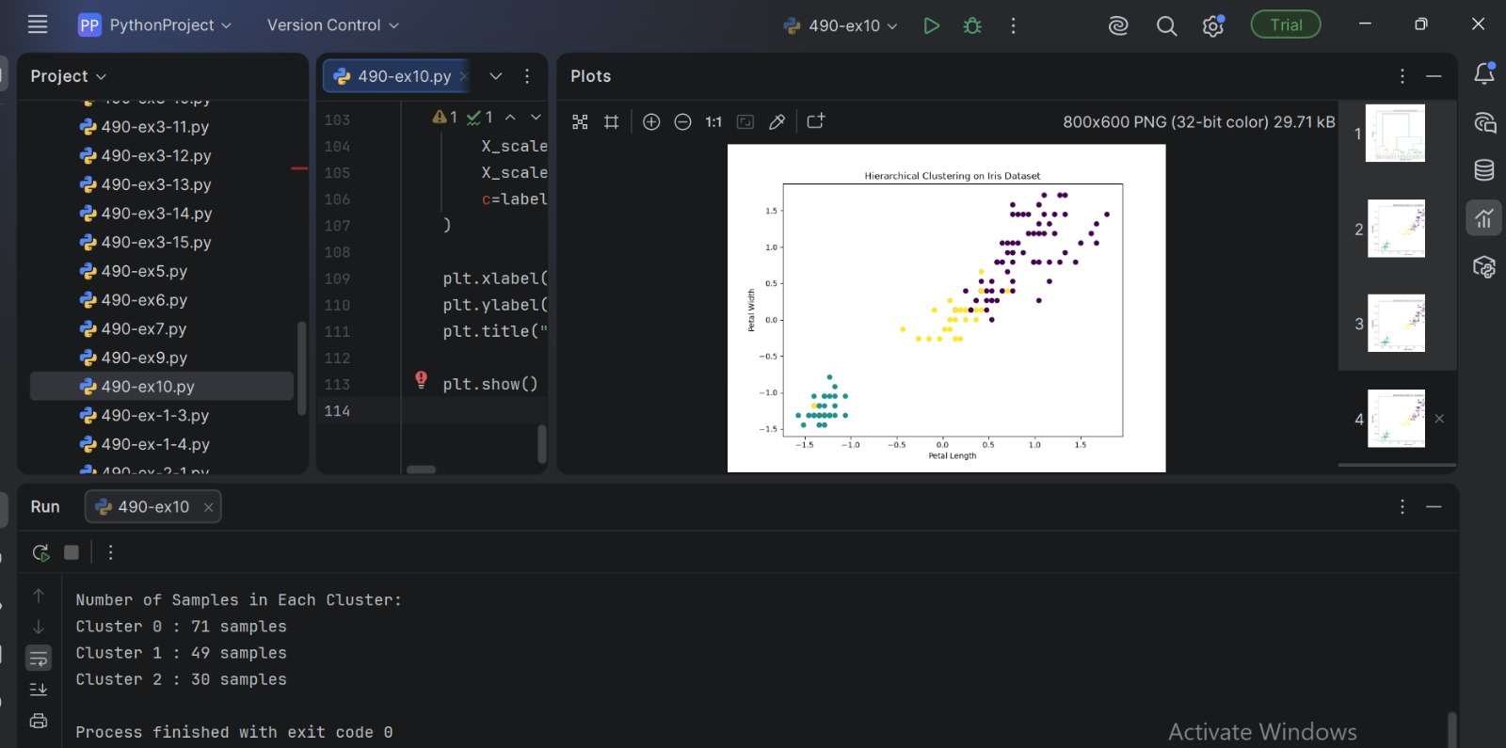

EX-11 : IMPLEMENT RANDOM FOREST AND ANALYZE PERFORMANCE
PROGRAM :

# Random Forest Classification using Iris Dataset

from sklearn.datasets import load_iris
from sklearn.model_selection import train_test_split
from sklearn.ensemble import RandomForestClassifier
from sklearn.metrics import (
accuracy_score,
confusion_matrix,
classification_report
)
import matplotlib.pyplot as plt
import seaborn as sns

# 1. Load Iris dataset
iris = load_iris()

X = iris.data
y = iris.target

# 2. Split dataset into training and testing sets
X_train, X_test, y_train, y_test = train_test_split(
X, y,
test_size=0.20,
random_state=42,
stratify=y
)

# 3. Create Random Forest model
model = RandomForestClassifier(
n_estimators=100,
random_state=42
)

# 4. Train the model
model.fit(X_train, y_train)

# 5. Make predictions
y_pred = model.predict(X_test)

# 6. Calculate accuracy
accuracy = accuracy_score(y_test, y_pred)

print("Random Forest Classification")
print("----------------------------")
print("Number of trees:", 100)
print("Accuracy:", accuracy)

# 7. Confusion Matrix
cm = confusion_matrix(y_test, y_pred)

print("\nConfusion Matrix:")
print(cm)

# 8. Classification Report
print("\nClassification Report:")
print(classification_report(
y_test,
y_pred,
target_names=iris.target_names
))

# 9. Display Confusion Matrix
plt.figure(figsize=(6, 4))
sns.heatmap(
cm,
annot=True,
fmt="d",
cmap="Blues",
xticklabels=iris.target_names,
yticklabels=iris.target_names
)

plt.xlabel("Predicted Class")
plt.ylabel("Actual Class")
plt.title("Random Forest - Confusion Matrix")
plt.show()

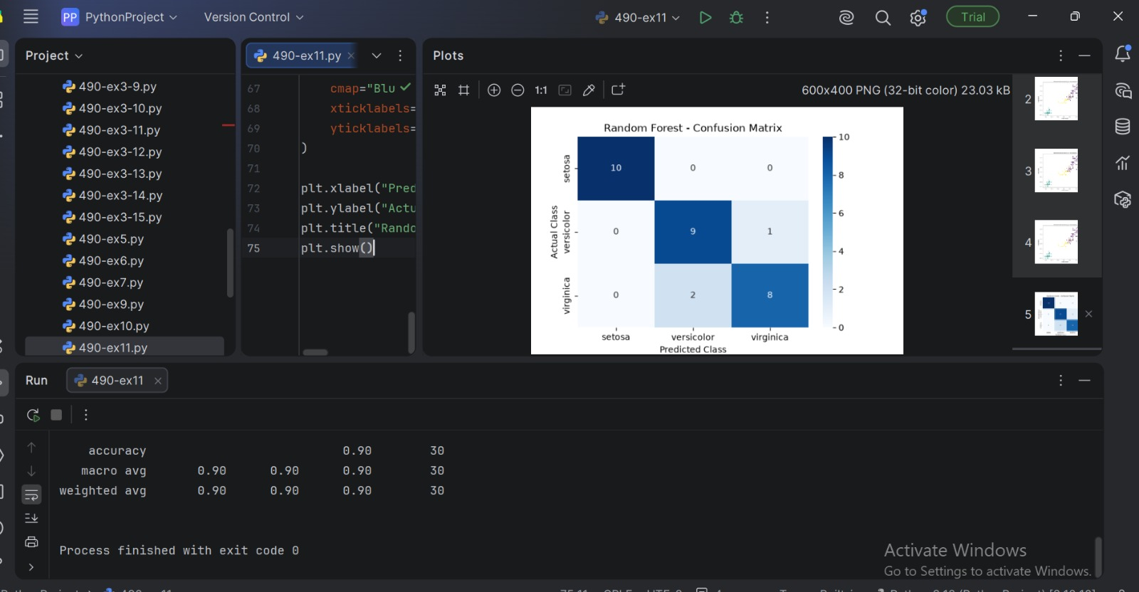

EX-12 : IMPLEMENT BOOSTING TECHNIQUES AND COMPARE RESULTS

PROGRAM :
# Implement Boosting Techniques and Compare Results
# Dataset: Iris

from sklearn.datasets import load_iris
from sklearn.model_selection import train_test_split
from sklearn.ensemble import AdaBoostClassifier, GradientBoostingClassifier
from sklearn.metrics import accuracy_score, precision_score, recall_score, f1_score
import matplotlib.pyplot as plt

# 1. Load dataset
iris = load_iris()

X = iris.data
y = iris.target

# 2. Split dataset
X_train, X_test, y_train, y_test = train_test_split(
X, y,
test_size=0.20,
random_state=42,
stratify=y
)

# 3. Create AdaBoost model
ada_model = AdaBoostClassifier(
n_estimators=100,
random_state=42
)

# 4. Create Gradient Boosting model
gb_model = GradientBoostingClassifier(
n_estimators=100,
random_state=42
)

# 5. Train models
ada_model.fit(X_train, y_train)
gb_model.fit(X_train, y_train)

# 6. Predictions
ada_pred = ada_model.predict(X_test)
gb_pred = gb_model.predict(X_test)

# 7. Function to calculate performance
def evaluate_model(name, y_test, y_pred):
accuracy = accuracy_score(y_test, y_pred)
precision = precision_score(
y_test, y_pred, average="weighted"
)
recall = recall_score(
y_test, y_pred, average="weighted"
)
f1 = f1_score(
y_test, y_pred, average="weighted"
)

print("\n", name)
print("-" * 30)
print("Accuracy :", round(accuracy, 4))
print("Precision:", round(precision, 4))
print("Recall :", round(recall, 4))
print("F1-Score :", round(f1, 4))

return accuracy, precision, recall, f1

# 8. Evaluate AdaBoost
ada_results = evaluate_model(
"AdaBoost",
y_test,
ada_pred
)

# 9. Evaluate Gradient Boosting
gb_results = evaluate_model(
"Gradient Boosting",
y_test,
gb_pred
)

# 10. Compare accuracy
models = ["AdaBoost", "Gradient Boosting"]
accuracies = [
ada_results[0],
gb_results[0]
]

plt.figure(figsize=(7, 5))
plt.bar(models, accuracies)

plt.xlabel("Boosting Technique")
plt.ylabel("Accuracy")
plt.title("Comparison of Boosting Techniques")

plt.ylim(0, 1.1)
plt.show()

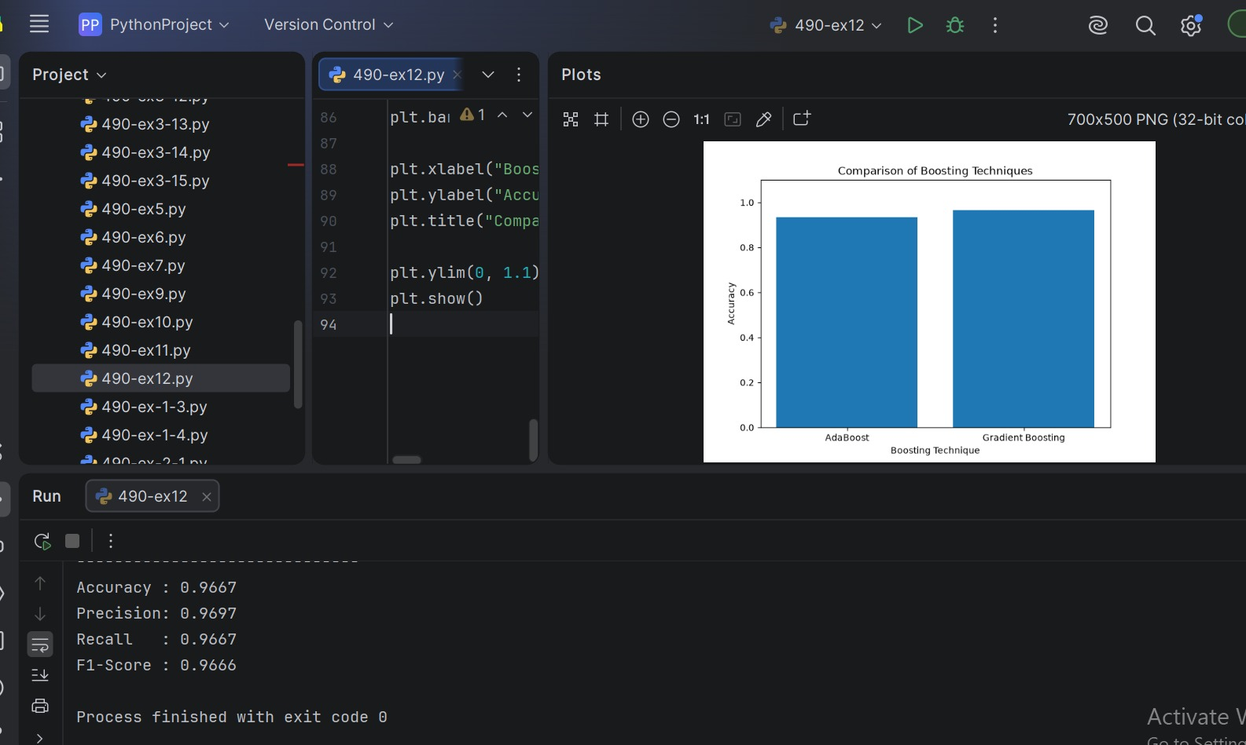

EX-13: IMPLEMENT A BASIC REINFORCEMENT LEARNING MODEL
PROGRAM :
import numpy as np
import random

# Number of states and actions
num_states = 5
num_actions = 2

# Actions
# 0 = Left
# 1 = Right

# Initialize Q-table
Q = np.zeros((num_states, num_actions))

# Parameters
alpha = 0.1 # Learning rate
gamma = 0.9 # Discount factor
epsilon = 0.2 # Exploration probability
episodes = 1000

# Environment function
def get_next_state(state, action):

if action == 0: # Move Left
next_state = max(0, state - 1)
else:
# Move Right
next_state = min(num_states - 1, state + 1)

# Reward
if next_state == 4:
reward = 10
else:
reward = -1

return next_state, reward

# Q-Learning
for episode in range(episodes):

state = 0

while state != 4:

# Epsilon-greedy action selection
if random.random() < epsilon:
action = random.randint(0, 1)
else:
action = np.argmax(Q[state])

# Perform action
next_state, reward = get_next_state(state, action)

# Q-learning update
Q[state, action] = Q[state, action] + alpha * (
reward +
gamma * np.max(Q[next_state]) -
Q[state, action]
)

state = next_state

# Display Q-table
print("Learned Q-Table:")
print(Q)

# Test the learned policy
state = 0
path = [state]

while state != 4:

action = np.argmax(Q[state])

next_state, reward = get_next_state(state, action)

state = next_state
path.append(state)

print("\nLearned Path:")
print(path)

print("\nOptimal Policy:")
for state in range(num_states - 1):

action = np.argmax(Q[state])

if action == 0:
print("State", state, "-> Left")
else:
print("State", state, "-> Right")

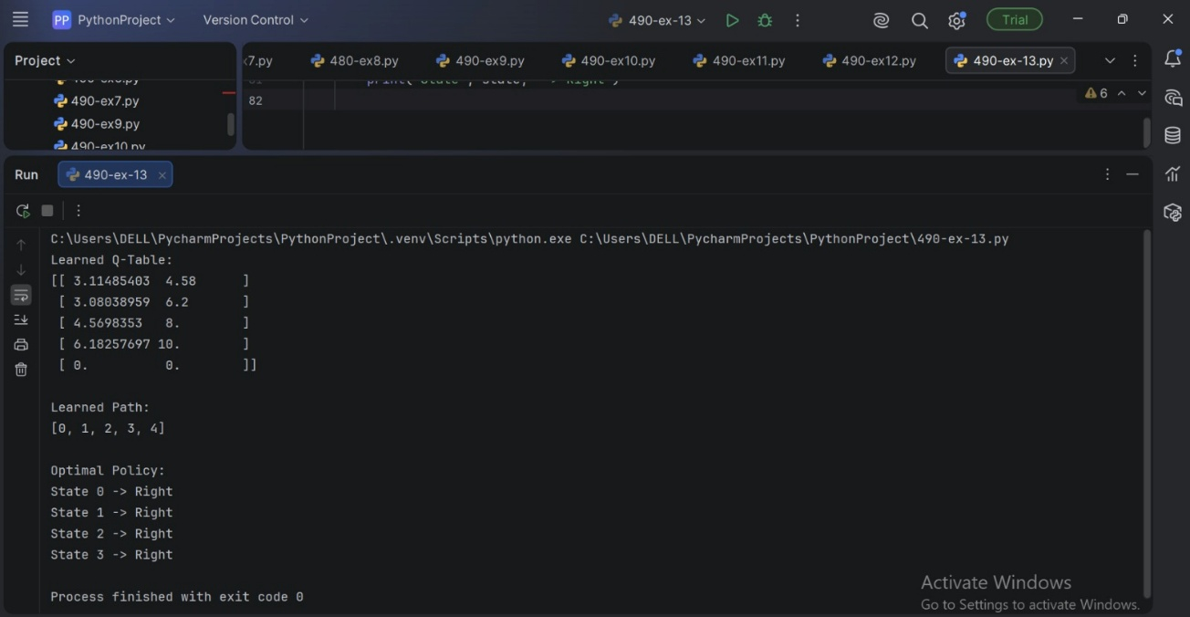

EX-14 : BUILD A NEURAL NETWORK USING TENSORFLOW/KERAS

PROGRAM :

# Build a Neural Network using TensorFlow/Keras
# Dataset: Iris

import numpy as np
Import tensorflow as tf

from tensorflow.keras.models import Sequential
from tensorflow.keras.layers import Dense

from sklearn.datasets import load_iris
from sklearn.model_selection import train_test_split
from sklearn.preprocessing import StandardScaler
from sklearn.metrics import accuracy_score, classification_report

# 1. Load Iris dataset
iris = load_iris()

X = iris.data
y = iris.target

# 2. Split dataset
X_train, X_test, y_train, y_test = train_test_split(
X, y,
test_size=0.20,
random_state=42,
stratify=y
)

# 3. Standardize features
scaler = StandardScaler()

X_train = scaler.fit_transform(X_train)
X_test = scaler.transform(X_test)

# 4. Build neural network
model = Sequential([
Dense(16, activation='relu', input_shape=(4,)),
Dense(8, activation='relu'),
Dense(3, activation='softmax')
])

# 5. Compile model
model.compile(
optimizer='adam',
loss='sparse_categorical_crossentropy',
metrics=['accuracy']
)

# 6. Display model architecture
model.summary()

# 7. Train the model
history = model.fit(
X_train,
y_train,
epochs=50,
batch_size=8,
validation_split=0.2,
verbose=1
)

# 8. Evaluate model
loss, accuracy = model.evaluate(X_test, y_test, verbose=0)

print("\nTest Loss:", round(loss, 4))
print("Test Accuracy:", round(accuracy, 4))

# 9. Make predictions
y_probability = model.predict(X_test, verbose=0)

y_pred = np.argmax(y_probability, axis=1)

# 10. Classification report
print("\nClassification Report:")
print(classification_report(
y_test,
y_pred,
target_names=iris.target_names
))

